10/25/2024

**AKOLA MUNICIPAL CORPORATION**

**TRADE LICENCE**

**MUNICIPAL TRADE LICENCE**

**Work flow of Trade License**

Dated : 16-01-2024

1. **Role:**
2. **JSK/Citizen/** – Form fills for trade license
3. **Back office** – Document upload and editing form
4. **Lipik** – Document verifies and forward to section head
5. **1 Inspector (To check on Field)*** (Not Specify this condition)**
6. **Section Head** – Re-verify the document and forward to DMC for final approval.
7. **DMC** – Final approval of trade license
8. **JSK** – Payments receive and issue trade license.
9. **Trade Module**
10. Process of acquiring a new trade license
11. **What are the factors involved in tax calculation like business area, rates of different kinds of business and license for years.**

Response: Presently, AMC employs an offline procedure for the issuance of trade licenses to applicants. The sequential actions involved are outlined as follows:

1. Applicants are required to manually complete the provided form (attached in PDF format) and submit it alongside the subsequent documents:

* Copy of the Shop Act (a corroborative document confirming shop registration)
* Proof of the current year's property tax payment (applicants are mandated to clear their property tax for the ongoing year prior to initiating the trade license application)
* Photograph of the applicant along with a depiction of the shop
* NOC (No Objection Certificate) from the Nagar Rachna Vibhag (Town Planner Department) pertaining to the structural layout of the establishment.
* Food & Drug license for establishments such as hotels, restaurants, medical shops, hospitals, and analogous service providers.
* Fire clearance issued by the Fire-fighting department.

1. Trade licenses issued by AMC are exclusively applicable to commercial premises. Residential premises used for commercial activities do not qualify for trade license issuance.
2. A comprehensive rate chart encompasses 320 distinct trade categories. Separate rate structures are allocated for businesses in the food and lodging sector, as well as nursing homes. A copy of this rate chart is provided in the attached PDF.
3. AMC releases trade licenses on an annual basis, which can subsequently be either renewed or voluntarily surrendered.
4. **Who are the persons involved in issuing the trade license?**

**Response: Following persons are involved in issuing the trade license:**

* Deputy Municipal Commissioner
  + Head of Department
    - 1 Clerk
      * 1 Operator
        + 1 Inspector (To check on field)

1. **Rate chart of the business license:**

Response: PDF copy attached.

1. **Rules for Renewal, Amendment or Surrender of the trade license.**
2. Effect of license charge in these processes.
3. **Renewal Process**: An exclusive form (enclosed in the attached PDF) is designated for the trade license renewal. The renewal procedure mirrors the initial application process, with the exemption of not requiring applicants to resubmit accompanying documents for renewal.
4. **Surrender Procedure**: In cases of voluntary surrender of trade licenses, applicants must submit an application for surrender along with a receipt confirming payment of the current year's property tax.

**Cancellation Protocol**: Instances of trade license cancellation arise upon the receipt and verification of complaints against the trader in question.

1. **General Points:**
2. **Payment through cheque:** Provisional payment receipt shall be issued in case of cheque payment and once the cheque gets cleared then the final payment receipt will be issued.
3. **Data Clean:** Please clean the old data used for test case.
4. **Collection Report:** Daily collection report shall be generated separately (in **PDF and Excel**) and simultaneously the collection of trade license fees must be reflecting into consolidated collection report for verification (Cash and Bank) at Santosh id.
5. **Msg Notification:** Notification shall be sent to applicant after approval of trade license and payment of trade license fee.

**AMC Trade Licence Required Documentation (Mandatory or not)**

**For New Trade Licence Documents Requirement**

1. Shop Act (Mandatory /Not Mandatory )
2. NOC (Mandatory /Not Mandatory )
3. Fire Clearance (Mandatory /Not Mandatory )
4. Current Paid Holding Tax Receipt (Mandatory /Not Mandatory )
5. ID proof
6. Photograph

**For Renewal Trade Licence Documents Requirement**

1. Previous Trade Licence (Mandatory /Not Mandatory )
2. Current Paid Holding Tax Receipt (Mandatory /Not Mandatory )
3. ID Proof (Mandatory /Not Mandatory )
4. Photograph (Mandatory /Not Mandatory )

**Surrender Trade Licence Documents Requirement**

1. Current (Valid) Trade Licence. (Mandatory /Not Mandatory )
2. Current Paid Holding Tax Receipt (Mandatory /Not Mandatory )
3. ID Proof (Mandatory /Not Mandatory )
4. Affidavit (Notary) For Surrender (Mandatory /Not Mandatory )

**Amendment Trade Licence Document Requirement**

1. Current (Valid) Trade Licence. (Mandatory /Not Mandatory )
2. Current Paid Holding Tax Receipt (Mandatory /Not Mandatory )
3. ID Proof (Mandatory /Not Mandatory )
4. Affidavit (Notary) for Amendment (Mandatory /Not Mandatory )

**Municipal Trade License Fee Management System**

According to the Municipal Trade License Act permission is required from urban local bodies to set up trade in their jurisdiction. No premises can be used for any non-residential purpose without a Municipal Trade License. The owner or occupier of every place for the use of which for any purpose a license is required shall apply to the Commissioner/ Executive Officer/ The authority to issue licenses in respect of trades or business specified in the schedule shall be the Municipal Commissioner/ Executive Officer.

**Procedure**

* To set up or run a business unit in area of urban local bodies, applicant must submit its application by paying applicable Municipal Trade License fees.
* The disposal of application will be passed through four tier verification i.e., Primary verification by Lipik, secondary verification by **Section Head**, approval/ refusal of application by Approved Authority.
* After primary verification on application details, Lipik will forward the application to Section Head for secondary verification. Section Head will review the technical aspect of the application for recommendation on approval or disapproval to Approval Authority. The disapproval will depend upon the form not property filled or the documents not being in order. Approval Authority may instruct

|  |  |
| --- | --- |
| **Approval Process of Municipal Trade License in Urban Local Bodies – Site Inspection** | |
| Hierarchy | Role & Responsibility |
| Lipik | * Review all documents and remarks on documents. * Forward the file to Section Head |
| ATS | * Final Review of the application with attached documents and remarks * Prepare recommendation note for issuing certificate or Prepare objection note for rejection of issuing certificate * Forward the recommendation to approval authority or Send back the application to applicant if necessary |
| Tax Superintendent | * Review all remarks with documents * Issue Municipal Trade License Certificate or Reject the application to issue the certificate or Send back to the application to Section Head if necessary |
|  |

**Trade Workflow Chart**

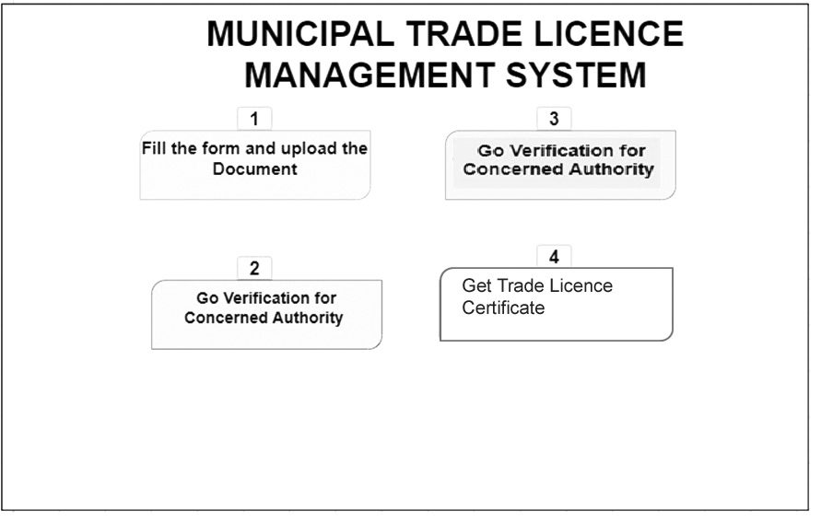

* 1. **Documents required for issuing Municipal Trade License**
     + - **In case trader applicant is the owner of business premises**

Enclose Land Possession Certificate/ Allotment Order/ Revenue Rent/ Sale Deed/ Correction slip/ Updated Holding Tax

Or

**If** **applicant** **has** **no** **Land/** **Building** **of** **his** **/her** **own**

Enclose Deed of Land Lease Agreement/ Rent Agreement/ Electricity Bill

* + - * **If partnership Firm**

Enclose Deed or Agreement

Or

**If Business is Pvt. Ltd. Or Ltd Company**

Enclose Registration Certificate incorporating under the companies Act

**Or if applicant is individual**

Identity proof of Trade applicant

**Municipal Trade License Fees**

As per Trade Code Fixed amount

* 1. **Municipal trade licence renewal**

Every Trade License shall expire at the end of the 12 months from the issue date of license. The grantee needs to apply for renew the license before 1 month from the date of expiry. Normally, there will not be an inspection of the trade premises for renewal. However, Original Municipal Trade License will be mandatory document to renew the trade license. On the advent of online Municipal Trade License Management, the grantee may renew its Municipal Trade License through this online application.

* 1. **Suspend /Revoke Municipal Trade licence**

Any license or permission granted earlier may at any time, be suspended or revoked by the approval authority of

ULB, by whom it was granted under the following circumstances

* + - * It has been secured by the grantee through misrepresentation or fraud
      * If any of the restriction or conditions of license or permission has been infringed or evaded by grantee
      * If the grantee has been convicted for the contravention of any of the provisions of the Act When any such license or permission is suspended or revoked, the grantee shall be deemed to be without a license or permission until the license or the permission is renewed or issued
      * The Approval Authority of ULB may send the hearing notice. The hearing date maybe extended to maximum fifteen working days from the date of issuing the notice
  1. **Surrender of Municipal Trade Licence**

The grantee may surrender its Municipal Trade License within validity period. No fees will be levied on surrender of the Municipal Trade License. Original Trade License will be mandatory document for surrender

* 1. **Amendment of Municipal Trade Licence**

Once the license permission granted, it will remain in force till its validity period. The grantee may apply for change in the trade if he/she is changing the trade within the same premises, or in case the covered area of the trade is being increased or decreased. The renewed license will be given after depositing the relevant fee and required documents.

* 1. **Terms and Conditions**

1. If the license holder wants to renew this license, it will be done before the end of March in the year in which the license expires.
2. If the businessman wants to close the business, he should submit the license to the license department by paying the current year's license fee and applying properly to the license department.
3. The license should be framed and affixed to the facade of the place of business.
4. The license cannot be used as a right to the premises, a claim to the premises, alteration of Government / Municipal records or proof of premises.
5. Licensee shall be responsible for any loss, damage to property and loss of life in the course of his business.
6. In case of complaint in respect of construction permit of commercial property, the said permit shall be canceled based on the facts in the complaint.
7. Government of Maharashtra Order No.Sankeerna-2017/P.No.168/T.K.4, dated 2nd January 2018 should not use, store, distribute, sell products made from plastic / thermocol in your business. If found, action will be taken as per the said order.
8. Licensing Officer reserves the right to cancel the license in case of a cognizable complaint from the citizens and found to be true.
9. The above terms and conditions of the license should be strictly followed otherwise the licensing authority reserves the right to cancel your license.
10. Traders selling food and food items should keep the place of business clean for the health of citizens.
11. Strict compliance of Solid Waste Management Rules-2016 shall remain mandatory.
    1. **Cancellation of Trade Licence**

A License issued under the provision of these regulations shall be cancelled: -

* + - * If the licensee fails to abide by the conditions laid down in the license.
      * If the premises of the shop has been shifted without approval of the concerned authority.
      * If container for disposing garbage and refuses is not available within the premises.
      * If the license carries on or permits to be carried on, any other trade in the license premises, except the trade mentioned in the license; and if it becomes evident that the running of the trade has created a public nuisance and polluted the vicinity.
      * If it becomes evident that the information submitted in is a misrepresentation of fact or mistake.
      * If the licensee fails to display a notice board containing the nature of articles, which he is exposing or offering for sale in accordance with the instructions issued by the ULB from time to time;
      * If found that the license has been sublet.
      * If it is found that licensee is carrying on his business in an unapproved building.
  1. **Functional Requirements: Municipal Trade License**

|  |  |
| --- | --- |
| 8.1 | * System should allow the approving authority to approve or reject the report |
| 8.2 | * The system should enable the applicant to receive SMS alerts about the date of the inspector's inspection or visit, as well as the approval or rejection of the application |
| 8.3 | * System should have ability to allow approving or rejecting the report |
| 8.4 | * System should be able to maintain& generate the records of notice |
| 8.5 | * System should have facility for Generation of Notice |
| 8.6 | * System should have facility to enter the details of dishonored Cheques |
| 8.7 | * Capturing of the license fee/late fee details (Cheque/DD details, online, through banks etc) |
| 8.8 | * System should have the facility of Cancellation of License by Force |
| 8.9 | * System should have ability to do the scrutiny of applications |
| 8.10 | * System should have the facility to assign unique identification number based on license type, which will be used for all future transactions of the license |
| 8.11 | * System should allow the applicant to apply for a license for multiple years |
| 8.12 | * System should allow generation of license and intimation to applicant through SMS or e-mail or Whats-app |
| 8.13 | * The system should allow generating paper-based license |
| 8.14 | * The system should have provision to issue duplicate trade licence |
| 8.15 | * The system should have provision to renew the existing trade licence |
| 8.16 | * The system should have provision to change the name of the business |
| 8.17 | * The system should have facility to change in nature of business |
| 8.18 | * The system should have provision to surrender the market license by application |
| 8.19 | * The system should have provision to transfer the license under nomination (hereditary) |
| 8.20 | * The system should have provision to transfer the license via any other mode than nomination |
| 8.21 | * The system should allow the online payment for trade license fee |
| 8.22 | * The System should have facility to define rates for area taxes specific to particular license category |
| 8.23 | * System should have facility for maintenance of matrix for license fee details with an option to keep the records even after new rates become effective |
| 8.24 | * System should be able to identify and define the charges to be taken from Tax Master or Rate Chart for a particular service |
| 8.25 | * System should have facility to define license type - sub type, category – subcategory |
| 8.26 | * The system should be able to generate reminder notice for market license renewal based on individual license number |
| 8.27 | * The system should be able to generate the list defaulters who have not renewed their license after the license renewal date has expired |
| 8.28 | * The system should be able to generate the renewal notice for the defaulters who have not renewed their license after the license renewal date has expired |
| 8.29 | * The system should be able to generate any other fixed format and Ad-hoc reports as desired |
| 8.30 | * System should print Reports showing Changes in License Types, Business Partners, Cancellation Licenses, etc. |
| 8.31 | * System should have Facility to forecast the impact of reduction / deduction of License Fee |
| 8.32 | * System should print Reports writ. Bills / Notices generated |
| 8.33 | * System should allow the Generation of receipt for the payment |
| 8.34 | * System should generate the Reports showing the number of licenses approved/rejected |
| 8.35 | * System should generate the Report showing the number of licenses pending for approval/rejection |
| 8.36 | * System should print reports related to E-Mail / SMS/whatsapp to be sent to the owner upon transactions |
| 8.37 | * System should allow the SMS alerts to the applicant regarding the date of inspection / visit by the inspector, approval / rejection of the application |
| 8.38 | * The system should have the facility to deliver the service online& through Municipality Counter |
| 8.39 | * The portal should have all the information including the processes and documents required for the convenience of the citizen |
| 8.40 | * System should capture all the details required for application |
| 8.41 | * System should have the facility to apply online and through the JSK Counter |
| 8.42 | * System should have a facility for online payment and through the JSK Counter |
| 8.43 | * System should have a facility to calculate fixed rate charges as per business code |
| 8.44 | * However, in case any person is found to have committed such offence on a continuous basis, which has become his/her habit, then in case of such habitual offence a fine not exceeding Rs …………………../- per day, will be charged |
| 8.45 | * No fine under regulations ……………… of revised Akola Municipal Trade (License) Regulation, _______ shall be imposed for any trade license or renewed on or after date of this notification up to ____________ |
| 8.46 | * System should automatically send the alerts to the license holder 30 days before the renewal the license |
| 8.47 | * The system should be able to generate the report containing: License details/ License holders details/ Business details |
| 8.48 | * The system should maintain the details about License holder details, like, owner name, shop , address, purpose, date of issuance, license number etc |
| 8.49 | * The system should be able to generate report showing the summary of Collection amount of market department revenue |

* 1. **Trade License System**

|  |  |
| --- | --- |
| 9.1 | * The Trade License product provides a digital interface, allowing citizens to apply for the Trade License and subsequently make the payment online |
| 9.2 | * The Trade License product enables: |
| 9.3 | * Ease of doing business—Traders can apply for new licenses, renewals, amendments, and supplement a licenses |
| 9.4 | * Regulatory Tracking—Administrators can track and manage regulatory processes |
| 9.5 | * Shorter Timelines—It streamlines and automates business licensing processes and helps a business to be setup quickly |
| 9.6 | * Data-driven decision making —The application collates valuable information on the economic activity and employment opportunities in a ULB |

* 1. **List of features of Trade**

|  |  |
| --- | --- |
| List of Functionalities | Corresponding Features |
| Registration, Login, Creation of User Profile | * Provision for Language Selection during first time registration via Mobile/Web App.(Bilingual) * OTP Based Login for Citizen/Employee via Mobile/WebApp * Role based Login Credentials for various hierarchies of employee. * Provision of Personalized Profile for Citizen/Employee on WebApp * Registration facility for stakeholders (one time)   + For Agency   + For ULB Employee   + For Authorized Officers |
| Applying for a Trade License | * Citizen/JSK: Enters Trade Details, Trade Units, Accessories, and Owner Details * Citizen: Upload Documents * Citizen/ JSK: Calculation Breakup Based on area of shops * Citizen/JSK: Multiple Accessories Field Count * Citizen/JSK: Multiple Trade License * Citizen/JSK : Download/Print Application Summary * Citizen/JSK: Download/print Trade Reference No * Citizen/JSK: View the applied licenses |
| Steps for filling Trade License form | **Step-1:-** Mode of filling Trade License   * For citizen via online/web browser * For agency TC, door step service via mobile app /tab * For JSK, step in service via online/web portal   **Step-2:-** Details   * Fill firm type * Fill application type * Fill applicant details * Fill details of business * Fill type of ownership of business premises * Demand generate   **Step-3:-** If the citizen is filling the trade license then he has to upload the relevant documents. Whereas JSK/Agency TC will have to submit the document at back office but license fee cannot collected by them.  **Step-4:-** Verification of Application |
| Trade License Issue | * Document verifier : Verify document and put remarks * Lipik: View Details and forward * Sr. Lipik : Site Inspection and forward * Section Head : View details and forward * Executive officer : Review documents, Level verifications reports / reject/accept/ generate license certificate |
| Modification to a trade licence | * Edit/Update the application based on the inspection report against the application. |
| Renewal of Trade License | * Renew Trade License |
| Amendment of Trade License | * Amendment Trade license |
| Surrender of Trade license | * Surrender trade license |
| Suspended /Revoke | * Suspend /Revoke the Trade license |
| Payment and Fee | * Configurable workflow rights : Edit & Payment Collection |
| Dashboards and Reports | * For Admin Dashboard * View DCB comparison report * View new application/renewal application (Applied/Pending/Approval/Rejected) * View particular ward details * View particular ward wise household/shops * For ULB Dashboard * View DCB comparison report * View new/renewal/surrender applications * View particular ward details * View particular ward wise household/shops * Workflow |
| General Features | * Notifications : SMS notifications * Charges & Calculation :Calculation Engine * Charges & Calculation: Penalty – Date based * Charges & Calculation : Penalty |
| Configuration Master | * Configurable Workflow rights /Edit & Payment Collection * Configurable verification & Approval |

**MUNICIPAL TRADE LICENCE ACTIVITY LIST**

|  |  |
| --- | --- |
| **Module: Trade** **Role: Citizen** | |
| 1 | Citizen **Login** |
| 1.1 | Login Screen |
| 1.2 | Create New Citizen Screen |
| 1.3 | Citizen Dashboard Screen |
| 2 | Citizen **applies for a new Trade License** |
| 2.1 | Apply Screen |
| 2.2 | Notifications screen |
| 2.3 | Alerts Messages screen |
| 2.4 | Application List screen |
| 3 | Citizen **apply to renew Trade License** |
| 3.1 | Citizen Dashboard Screen |
| 3.2 | Citizen View License Screen |
| 3.3 | Citizen View Renew Trade License Screen |
| 4 | Citizen **applies for amendment of an existing license** |
| 4.1 | Citizen Dashboard Screen |
| 4.2 | Citizen View License Screen |
| 4.3 | Citizen Applies Amendment Trade License Screen |
| 5 | Citizen **Views any notifications against him/her** |
| 5.1 | Citizen can view any notifications against him/her via SMS/Whats-app |
| 5.2 | Citizen can view on portal |
| 6 | Citizen **Views Trade License Renewal History** |
| 6.1 | Citizen can view renewal history from web portal |
| 7 | Citizen **Views all the licenses issued against him** |
| 7.1 | Citizen Dashboard Screen |
| 7.2 | Citizen View License Screen |
| 7.3 | Citizen Views my licenses screen |
| 8 | **Log Out** |

|  |  |
| --- | --- |
| **Module: Trade** **Role: Jan Suvidha Kendra** | |
| 1 | JSK **Login** |
| 1.1 | Login Screen |
| 1.2 | Create New JSK Screen |
| 1.3 | JSK Dashboard Screen |
| 2 | JSK **accesses Trade Module from JSK Dashboard** |
| 2.1 | JSK Dashboard Screen |
| 3 | JSK **applies for a new trade license** |
| 3.1 | JSK Dashboard Screen |
| 3.2 | JSK Trade Apply Screen |
| 3.3 | JSK New Application Screen |
| 4 | JSK **renews citizens licenses** |
| 4.1 | JSK Dashboard Screen |
| 4.2 | JSK Trade Apply Screen |
| 4.3 | JSK Renew Application Screen |
| 5 | JSK **applies for amendment of an existing license** |
| 5.1 | JSK Dashboard Screen |
| 5.2 | JSK Trade Apply Screen |
| 5.3 | JSK Amendment Existing License Screen |
| 6 | JSK **applies for license surrender** |
| 6.1 | JSK Dashboard Screen |
| 6.1 | JSK Trade Apply Screen |
| 6.2 | JSK Surrender License Screen |
| 7 | JSK **Collect Payment** |
| 7.1 | JSK Dashboard Screen |
| 7.2 | JSK Trade Apply Screen |
| 7.3 | JSK New Application Screen |
| 7.4 | JSK Renew Application Screen |
| 7.5 | JSK Amendment Existing License Screen |
| 7.6 | JSK Surrender License Screen |
| 7.7 | JSK Payment Screen |
| 8 | JSK **Generate Payment Receipt** |
| 1.1 | JSK Dashboard Screen |
| 8.2 | JSK Trade Apply Screen |
| 8.3 | JSK New Application Screen |
| 8.4 | JSK Payment Screen |
| 8.5 | JSK Receipt Screen |
| 9 | JSK **View Payment Receipt Record** |
| 9.1 | JSK Dashboard Screen |
| 9.2 | JSK Trade license Screen |
| 9.3 | JSK Search Screen |
| 9.4 | JSK Action Screen |
| 9.5 | JSK Receipt Screen |
| 9.6 | JSK Download Receipt Screen |
| 10 | JSK **Track Application** |
| 10.1 | JSK Dashboard Screen |
| 10.2 | JSK Trade license Screen |
| 10.3 | JSK Search Screen |
| 10.4 | JSK Action Screen |
| 10.5 | JSK Track Application Screen |
| 11 | **Log Out** |

|  |  |
| --- | --- |
| **Module: Trade** **Role: Back Office User** | |
| 12 | Back office **Login** |
| 12.1 | Login Screen |
| 12.2 | Create New Back office Screen |
| 12.3 | Back office Dashboard Screen |
| 13 | Back office **accesses the trade workflow** |
| 13.1 | Back office Dashboard Screen |
| 14 | Back office **updates the incorrect form details based on documents provided** |
| 14.1 | BO Dashboard Screen |
| 14.2 | BO Trade Workflow Screen |
| 14.3 | BO Custom Tab Screen |
| 14.4 | BO Update Application Screen |
| 15 | Back office **uploads mandatory documents** |
| 15.1 | BO Dashboard Screen |
| 15.2 | BO Trade Workflow Screen |
| 15.3 | BO Action Screen |
| 15.4 | BO Uploads Document Screen |
| 16 | Back office **Sends application to the ULB Lipik** |
| 16.1 | BO Dashboard Screen |
| 16.2 | BO Trade Workflow Screen |
| 16.3 | BO Forward Screen |
| 17 | Back office **handles BTC applications** |
| 17.1 | BO Dashboard Screen |
| 17.2 | BO Trade Workflow Screen |
| 17.3 | BO View BTC Screen |
| 17.4 | BO Action Screen |
| 18 | Back office **Tracks the existing applications** |
| 18.1 | BO Dashboard Screen |
| 18.2 | BO Trade License Screen |
| 18.3 | BO Search Screen |
| 18.4 | BO Action Screen |
| 19 | Back office **accesses various reports** |
| 19.1 | BO Dashboard Screen |
| 19.2 | BO Trade Reports Screen |
| 19.3 | BO View Valid & Expired Report Screen |
| 19.4 | BO View EO Approved List Report Screen |
| 19.5 | BO View Trade Collection Report Screen |
| 19.6 | BO View Team Summary Report Screen |
| 19.7 | BO View Trade Collection Summary Report Screen |
| 19.8 | BO View Trade Level Pending Report Screen |
| 20 | **Log Out** |

|  |  |
| --- | --- |
| **Module: Trade** **Role: Lipik** | |
| 21 | Lipik **log in** |
| 21.1 | Login Screen |
| 22 | Lipik Processes **Trade License application** |
| 22.1 | Document review screen |
| 22.2 | Document Details Screen |
| 22.3 | Verify Trade License application & Documents screen |
| 23 | Lipik processes for **Renewal Application** |
| 23.1 | Document review screen |
| 23.2 | Document Details Screen |
| 23.3 | Verify Trade Renewal application & Documents screen |
| 24 | Lipik processes for **Amendment application** |
| 24.1 | Document review screen |
| 24.2 | Document Details Screen |
| 24.3 | Verify Amendment application & Documents screen |
| 25 | Lipik processes for **Surrender Application** |
| 25.1 | Surrender Application Form |
| 25.2 | Document review screen |
| 25.3 | Document Details Screen |
| 25.4 | Verify Surrender application & Documents screen |
| 26 | Lipik processes for **Searches Trade License** |
| 26.1 | Search Trade License Screen |
| 26.2 | Trade License Detail Screen |
| 26.3 | Trade License Payment History Screen |
| 26.4 | Receipt Screen |
| 26.5 | Comparative Demand Screen |
| 26.6 | Demand Receipt Screen |
| 27 | Lipik **Searches Pending Application** |
| 27.1 | Search Application Screen (New/Renewal/Surrender/Amendment) |
| 27.2 | Application Detail Screen |
| 28 | Lipik **Views His Recent Activity** |
| 28.1 | View recent activity in landing his screen |
| 29 | Lipik **Changes Password** |
| 29.1 | Lipik Dashboard |
| 29.2 | Dashboard Password selection screen |
| 30 | Lipik **Log Out** |

|  |  |
| --- | --- |
| **Module: Trade** **Role: Section Head (ATS)** | |
| 37 | **Section Head** **Login** |
| 37.1 | Login Screen |
| 37.2 | Create New SH Screen |
| 37.3 | SH Dashboard Screen |
| 38 | **Section Head** **accesses the trade workflow** |
| 38.1 | SH Dashboard Screen |
| 39 | **Section Head** **forwards application to the EO** |
| 39.1 | SH Dashboard Screen |
| 39.2 | SH Trade Workflow Screen |
| 39.3 | SH Action Screen |
| 39.4 | SH Forward Application Screen |
| 40 | **Section Head** **sends back application to the back office** |
| 40.1 | SH Dashboard Screen |
| 40.2 | SH Trade Workflow Screen |
| 40.3 | SH Action Screen |
| 40.4 | SH BTC Application Screen |
| 41 | **Section Head** **View the day to day activity** |
| 41.1 | SH Dashboard Screen |
| 41.2 | Pending Application Screen |
| 41.3 | Verify Application Screen |
| 41.4 | Rejected Application Screen |
| 42 | **Log Out** |

|  |  |
| --- | --- |
| **Module: Trade Role: Executive Officer (Tax Superintendent )** | |
| 43 | EO **Login** |
| 43.1 | Login Screen |
| 43.2 | Create New EO Screen |
| 43.3 | EO Dashboard Screen |
| 44 | EO **accesses workflow inbox screen** |
| 44.1 | EO Dashboard Screen |
| 45 | EO **approves an application screen** |
| 45.1 | EO dashboard screen |
| 45.2 | EO Trade Workflow Screen |
| 45.3 | EO Action Screen |
| 45.4 | EO Views Application Details Screen |
| 45.5 | EO Action Screen |
| 46 | EO sends **BTC’s application to the back office** |
| 46.1 | EO dashboard screen |
| 46.2 | EO Trade Workflow Screen |
| 46.3 | EO Action Screen |
| 47 | EO **Approve an application** |
| 47.1 | EO dashboard screen |
| 47.2 | EO Trade Workflow Screen |
| 47.3 | EO Action Screen |
| 47.4 | EO Approve Screen |
| 48 | EO **rejects an application** |
| 48.1 | EO dashboard screen |
| 48.2 | EO Trade Workflow Screen |
| 48.3 | EO Action Screen |
| 48.4 | EO Approve Screen |
| 49 | EO **View the day to day activity** |
| 49.1 | EO Dashboard Screen |
| 49.2 | Pending Application Screen |
| 49.3 | Verify Application Screen |
| 49.4 | Rejected Application Screen |
| 50 | **Log Out** |

|  |  |
| --- | --- |
| **Module: Trade** **Role: Accountant** | |
| 51 | Accountant **Logs In** |
| 51.1 | Login Screen |
| 52 | Accountant **Views Transactions Date to Date** |
| 52.1 | Views transaction screen |
| 52.2 | Views date to date screen |
| 52.3 | View recent activity in his landing screen |
| 53 | Accountant **Verifies Cash/Cheques/DD** |
| 53.1 | Views transaction screen |
| 53.2 | Reconcile the DD/Cheque |
| 53.3 | View recent activity in his landing screen |
| 54 | Accountant **Accepts Cash/Cheque and Provide Receipt Memo** |
| 54.1 | Views transaction screen |
| 54.2 | Generate receipt memo screen |
| 55 | Accountant **Views Recent Transactions** |
| 55.1 | Views transaction screen |
| 55.2 | View recent activity in his landing screen |
| 56 | Accountant **Logs Out** |

|  |  |
| --- | --- |
| **Module: Trade** **Role: Team Leader** | |
| 57 | Team Leader **Logs In** |
| 57.1 | Login Screen |
| 58 | Team Leader **Applies** |
| 58.1 | TL Dashboard |
| 58.2 | Ward Screen |
| 58.3 | New Form |
| 58.4 | Fee Review Screen |
| 58.5 | Document Details Screen |
| 58.6 | Document Upload Screen |
| 58.7 | Receipt Screen |
| 59 | Team Leader **Searches Applications** |
| 59.1 | Search Application Screen (New /Renewal) |
| 59.2 | Application Detail Screen |
| 59.3 | View recent activity in his landing screen |
| 60 | Team Leader **Searches Traders Number** |
| 60.1 | Search Traders Consumer Screen |
| 60.2 | Traders Consumer Detail Screen |
| 60.3 | Traders Consumer Demand Screen |
| 60.4 | Traders Consumer Payment History Screen |
| 61 | Search **Pending Applications and Payment** |
| 61.1 | Search Application Screen (New/Renewal) |
| 61.2 | Application Detail Screen |
| 61.3 | Demand Details Screen |
| 61.4 | Payment Screen |
| 61.5 | Receipt Screen |
| 62 | Team Leader **Logs Out** |

|  |  |
| --- | --- |
| **Module: Trade** **Role: Admin** | |
| 63 | Admin **Logs In** |
| 63.1 | Login Screen |
| 63.2 | Admin Dashboard |
| 64 | Admin **Views Analytical Dashboard** |
| 64.1 | Using different authority screen |
| 64.2 | All information shows in graphical representation screen |
| 65 | Admin **Views DCB** |
| 65.1 | View in DCB screen |
| 66 | Admin **Zone Specific** |
| 66.1 | View Zone wise details |
| 67 | Admin on **View information details** |
| 67.1 | View All activity details |
| 68 | Admin **Manages Roles and Permissions**. |
| 68.1 | Manages different roles for different permissions screen |
| 68.2 | Assign Role with zone and ward wise |
| 69 | Admin **Manages workflow And Permission** |
| 69.1 | Manages different workflow and permission screen |
| 69.2 | Manage Level workflow and permission |
| 70 | Admin **Views Reports** |
| 70.1 | Views reports screen |
| 70.2 | Views different parameters of reports screen |
| 71 | Admin **Searches Traders Consumer** |
| 71.1 | Search Traders Screen |
| 71.2 | Traders Detail Screen |
| 71.3 | Traders Demand Screen |
| 71.4 | Traders Payment History Screen |
| 71.5 | Payment Screen |
| 71.6 | Receipt Screen |
| 71.7 | Demand Receipt Screen |
| 72 | Admin **Searches Pending Application** |
| 72.1 | Search Application Screen |
| 72.2 | Application Detail Screen |
| 73 | Admin **Logs Out** |

**LEAGAL DOCUMENTS**

**IX. General provisions regarding licences and permits.**

(1) Whenever it is provided by or under this Act that a licence or a written permission may be given for any purpose, such licence or written permission shall specify the period for which, and the restrictions and conditions subject to which, the same is granted and the date by which an application for the renewal of the same shall be made and shall be given under the signature of the Commissioner or of a municipal officer empowered under section 69 to grant the same.

**1949 : LIX]** Maharashtra Municipal Corporations Act 237

II. Trade licenses and other licences for keeping animals and certain articles.

**376.**

1. Except under and in conformity with the terms and conditions of licence granted by the Commissioner, no person shall—
2. keep in or upon any premises any article specified in the rules—
3. in any quantity or in excess of the quantity specified in the rules as the maximum quantity of such article which may at one time be kept in or upon the same premises without a license, and
4. for any purpose whatever or for sale or for other than domestic use as may be specified in the case of each article in the rules ;
5. keep in or upon any buildings intended for or used as a dwelling or within fifteen feet of such building cotton, in pressed bales or boras or loose, in quantity exceeding four hundred-weight;
6. keep, or allow to be kept, in or upon any premises, horses, cattle or other four footed animals—
7. for sale,
8. for letting out in hire,
9. for any purpose for which any charge is made or any remuneration is received, or
10. for sale of any produce thereof;
11. carry on, or allow to be carried on, in or upon any premises—
12. any of the trades or operations connected with any trade specified in the rules ;
13. any trade or operation which in the opinion of the Commissioner is dangerous to life or health or property, or likely to create a nuisance either from its nature, or by reason of the manner in which, or the conditions under which, the same is, or is proposed to be, carried on ;
14. carry on within the City, or use any premises for, the trade or operation of a farrier.
15. A person shall be deemed to have known that a trade or operation is, in the opinion of the Commissioner, dangerous or likely to create a nuisance within the meaning of paragraph (ii) of caluse (d) of sub-section

(1), after written notice to that effect, signed by the Commissioner, has been served on such person or affixed to the premises to which it relates.

1. A person shall be deemed to carry on or to allow to be carried on a trade or operation within the meaning of clause (d) of sub-section (1) if he does any act in furtherance of such trade or is in any way engaged or concerned therein whether as principal, agent, clerk, master, servant, workman, handicraftsman or otherwise.
2. When any premises are used in the manner described in clause (c) or (d) of sub-section (1) it shall be presumed, until the contrary is proved, that the owner or occupier of such premises, or both the owner

and occupier have permitted such use.

Certain things not to be kept, and certain trades and operations not to be carried on, without

**IX. General provisions regarding licences and permits.**

**386.**

1. Except as may otherwise be provided by or under this Act, for every such licence or written permission a fee may be charged at such rate as shall from time to time be fixed by the Commissioner, with the sanction of the Corporation.
2. Subject to the provisions of the proviso to sub-section (1) of section 378, any licence or written permission granted under this Act may at any time be suspended or revoked by the Commissioner, if he is satisfied that it has been secured by the holder through misrepresentation or fraud or if any of its restrictions or conditions is infringed or evaded by the person to whom the same has been granted, or if the said person is convicted of an infringement of any of the provisions of this Act or of any rule, by-law or standing order in any matter to which such licence or permission relates.
3. When any such licence or written permission is suspended or revoked, or when the period for which the same was granted has expired, the person to whom the same was granted shall, for all purposes of this Act, be deemed to be without a licence or written permission, until the Commissioner’s order for suspending or revoking the licence or written permission is cancelled by him or until the licence or written permission is renewed, as the case may be : Provided that, when an application has been made for the renewal of a licence or permission by the date specified therein, the applicant shall be entitled to act as if it has been renewed, pending the receipt of orders.
4. Every person to whom any such licence or written permission has been granted shall, at all reasonable times, while such written permission or licence remains in force, if so required by the Commissioner, produce such licence or written permission.
5. Every application for a licence or permission shall be addressed to the Commissioner.
6. The acceptance by or on behalf of the Commissioner of the fee for a licence or permission shall not in itself entitle the person paying the fee to the licence or permission.

238 Maharashtra Municipal Corporations Act

**IV. Licences for private markets.**

**378.**

(1) No person shall without, or otherwise than in conformity with the terms of, a licence granted by the Commissioner in this behalf—

(a) keep open, or permit to be kept open, a private market ;

(b) use or permit to be used any place in the City as a slaughterhouse or for the slaughtering of any animal intended for human food ;

**1949 : LIX]**

1. Maharashtra Municipal Corporations Act 239 (c) use or permit to be used any place without the City, whether as a slaughter-house or otherwise, for the slaughtering of any animal intended for human food to be consumed in the City :

Provided that—

1. The Commissioner shall not refuse a licence for keeping open a private market lawfully established at the appointed day if application for such licence is made within two months thereof except on the ground that the place where the market is held fails to comply with any requirement of this Act or of the rules, by-laws or standing orders ;
2. The Commissioner shall not cancel or suspend or refuse to renew any licence for keeping open a private market for any cause other than the failure of the owner thereof to comply with some provision of this Act, or with some standing order or with some by-law ;
3. The Commissioner may cancel or suspend any licence for failure of the owner of a private market to give in accordance with the conditions of his licence a written receipt for any stallage, rent, fee, or other payment received by him or his agent from any person for the occupation or use of any stall, shop standing, shed, pen or other place therein ; nothing in this section shall be deemed to prevent the Commissioner from granting written permission for the slaughter of an animal in any place that he thinks fit, on the occasion of any festival or ceremony or under special circumstances.
4. When the Commissioner has refused, cancelled or suspended any licence to keep open a private market, he shall cause a notice of his having so done to be affixed in such language or languages as the

Corporation may from time to time specify on some conspicuous spot on or near the building or place where such market has been held.

**379.**

No person who knows that any private market has been established without the sanction of the Commissioner, or is kept open after a licence for keeping the same open has been refused, cancelled or

suspended by the Commissioner, shall sell or expose for sale therein any animal or articles of human food, or any live-stock or food for live-stock.

**380.**

No person shall slaughter any cattle, horses, sheep, goats or pigs for removing the skin thereof or cut up the carcass of any such animal at any place outside a municipal slaughter-house or a licensed

slaughter-house otherwise than in conformity with the written permission

of the Commissioner.

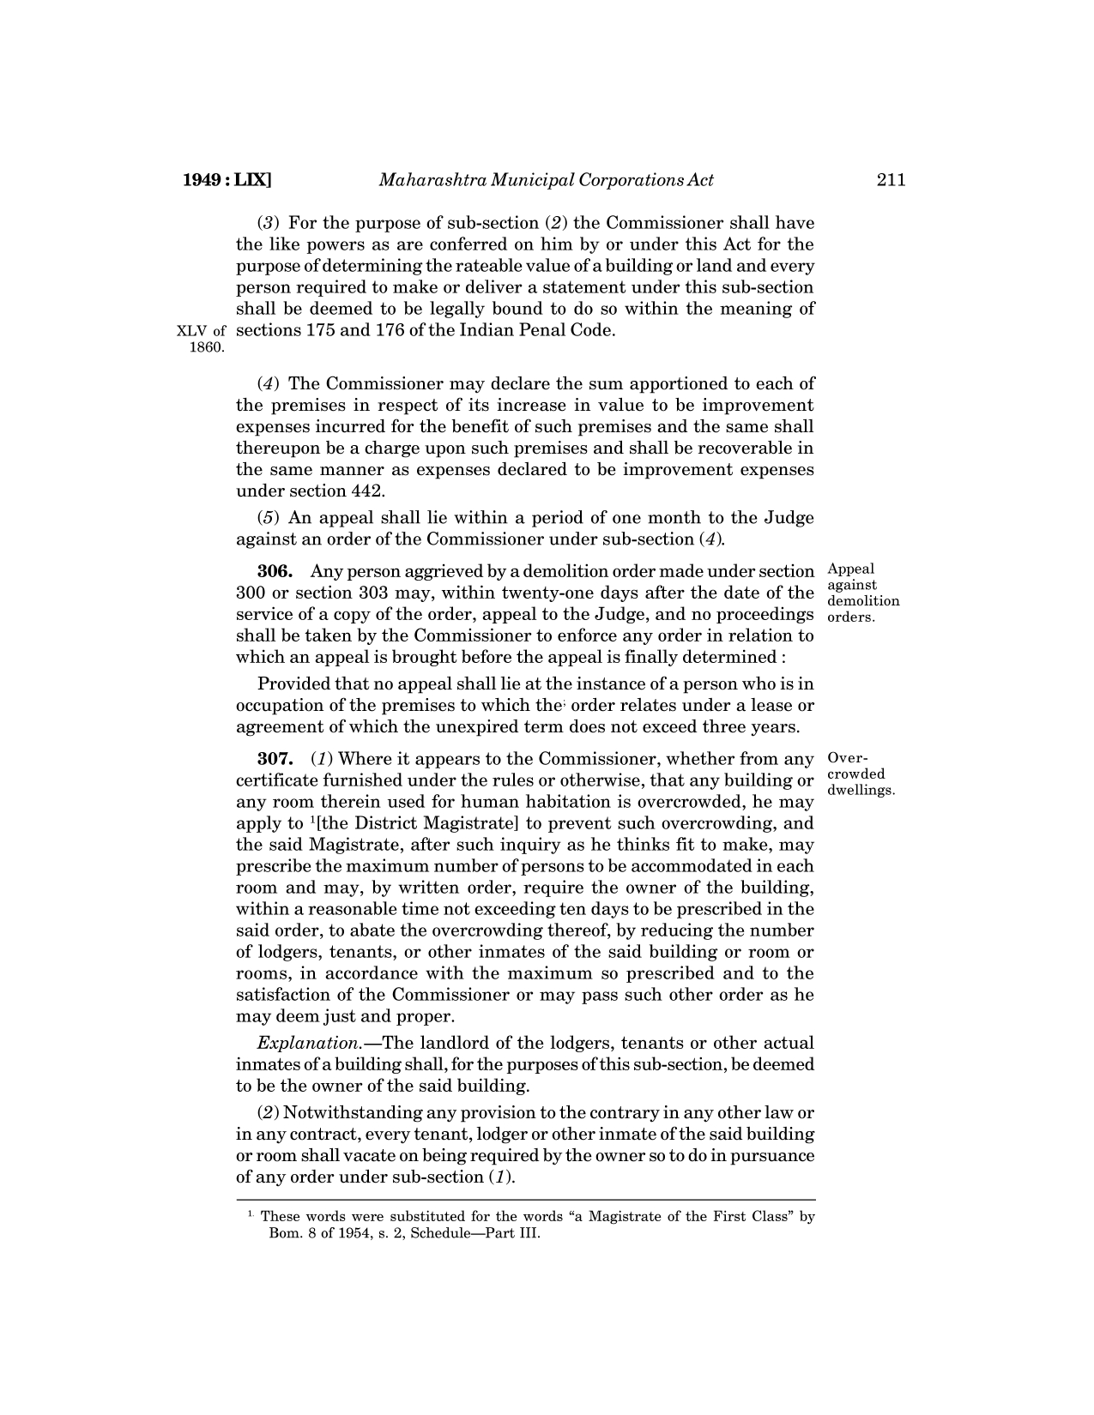

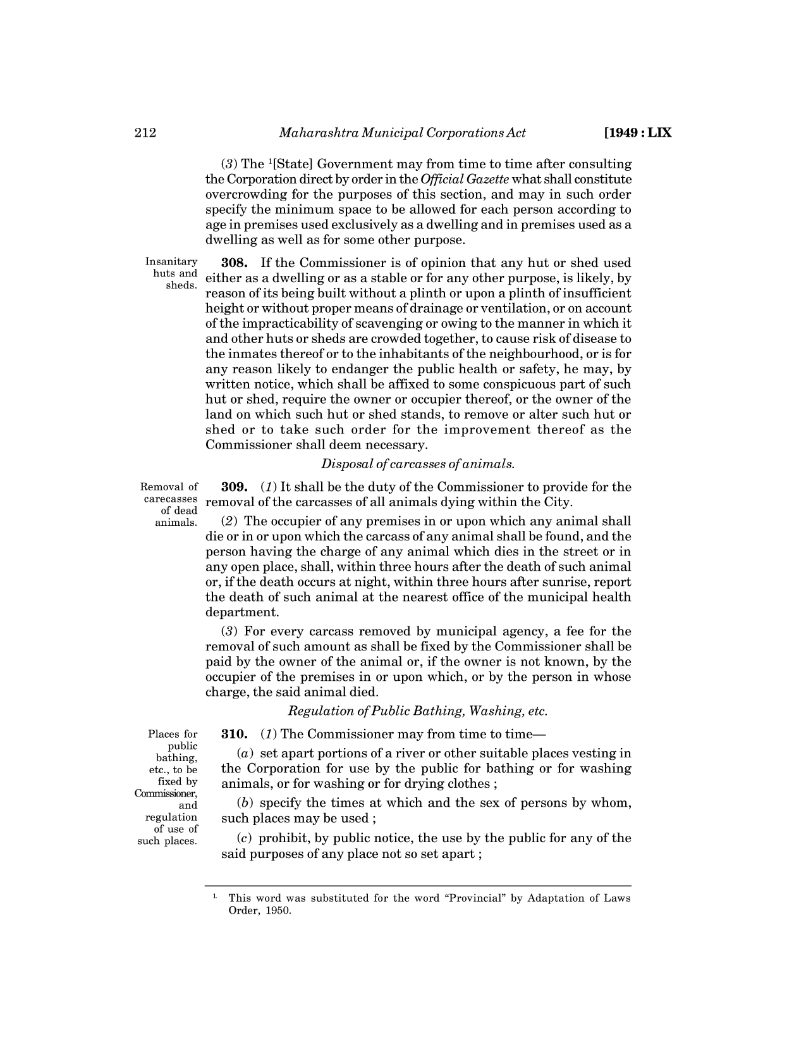

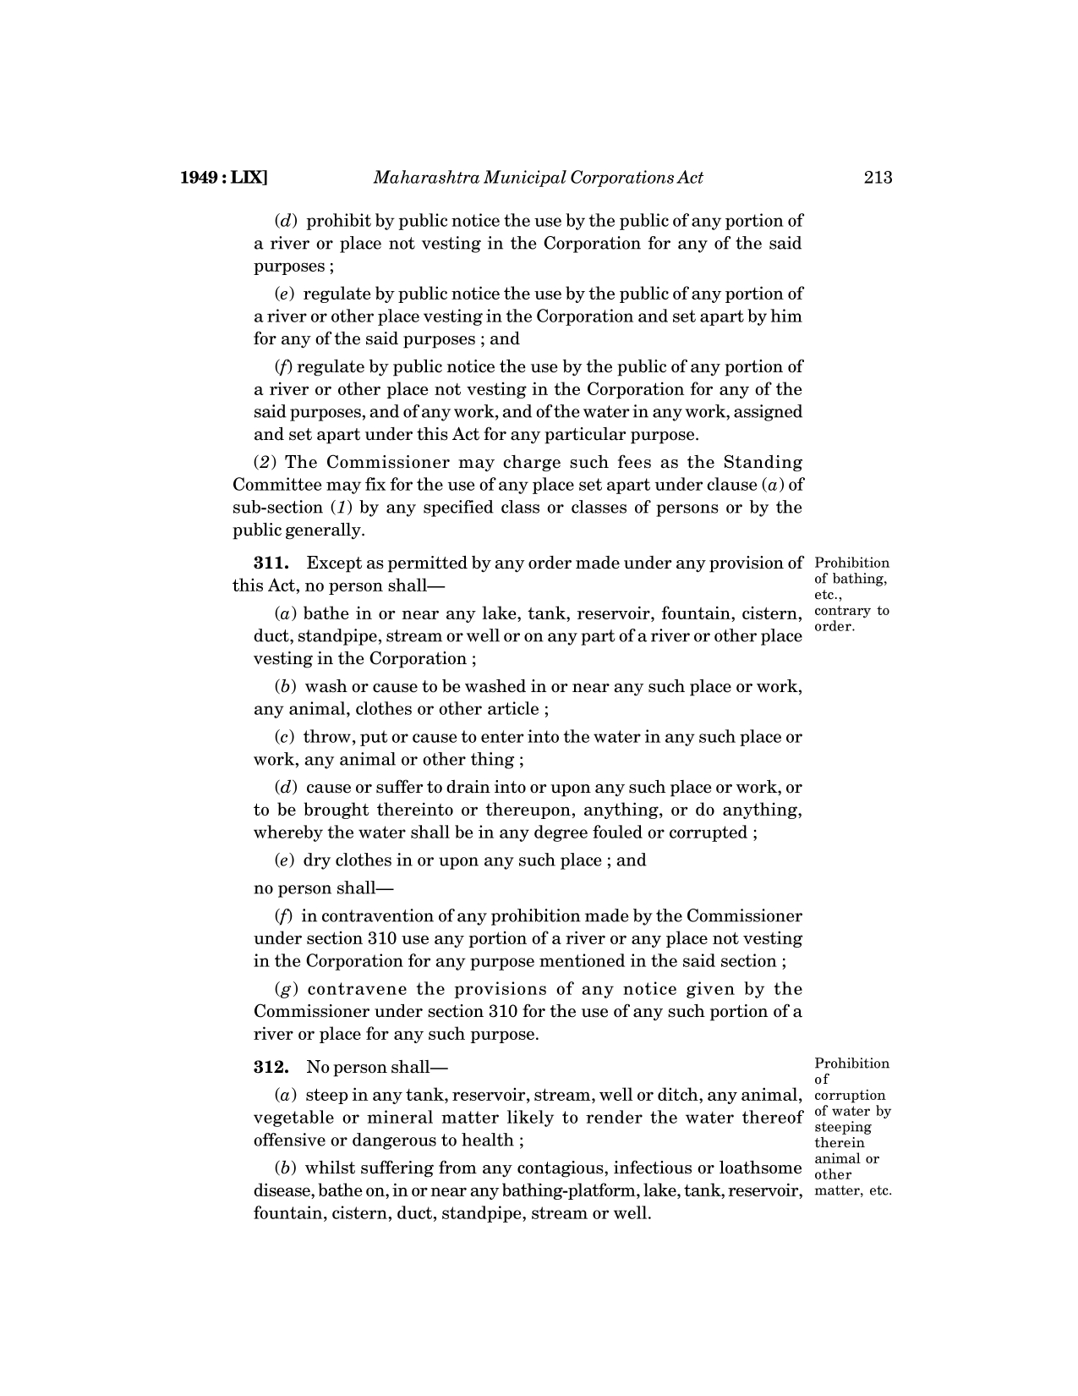

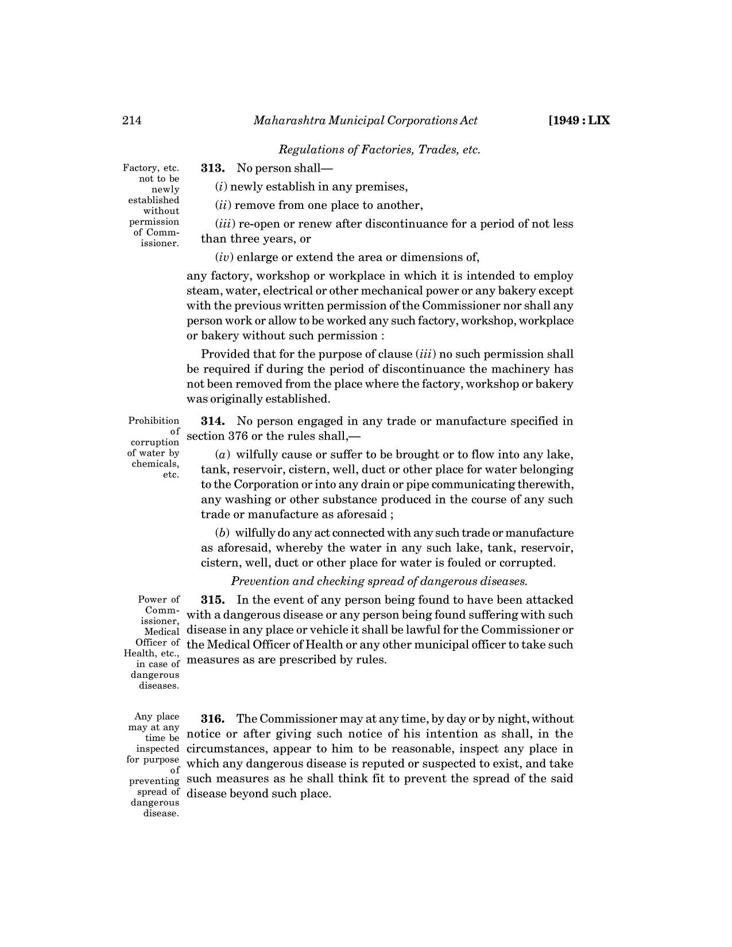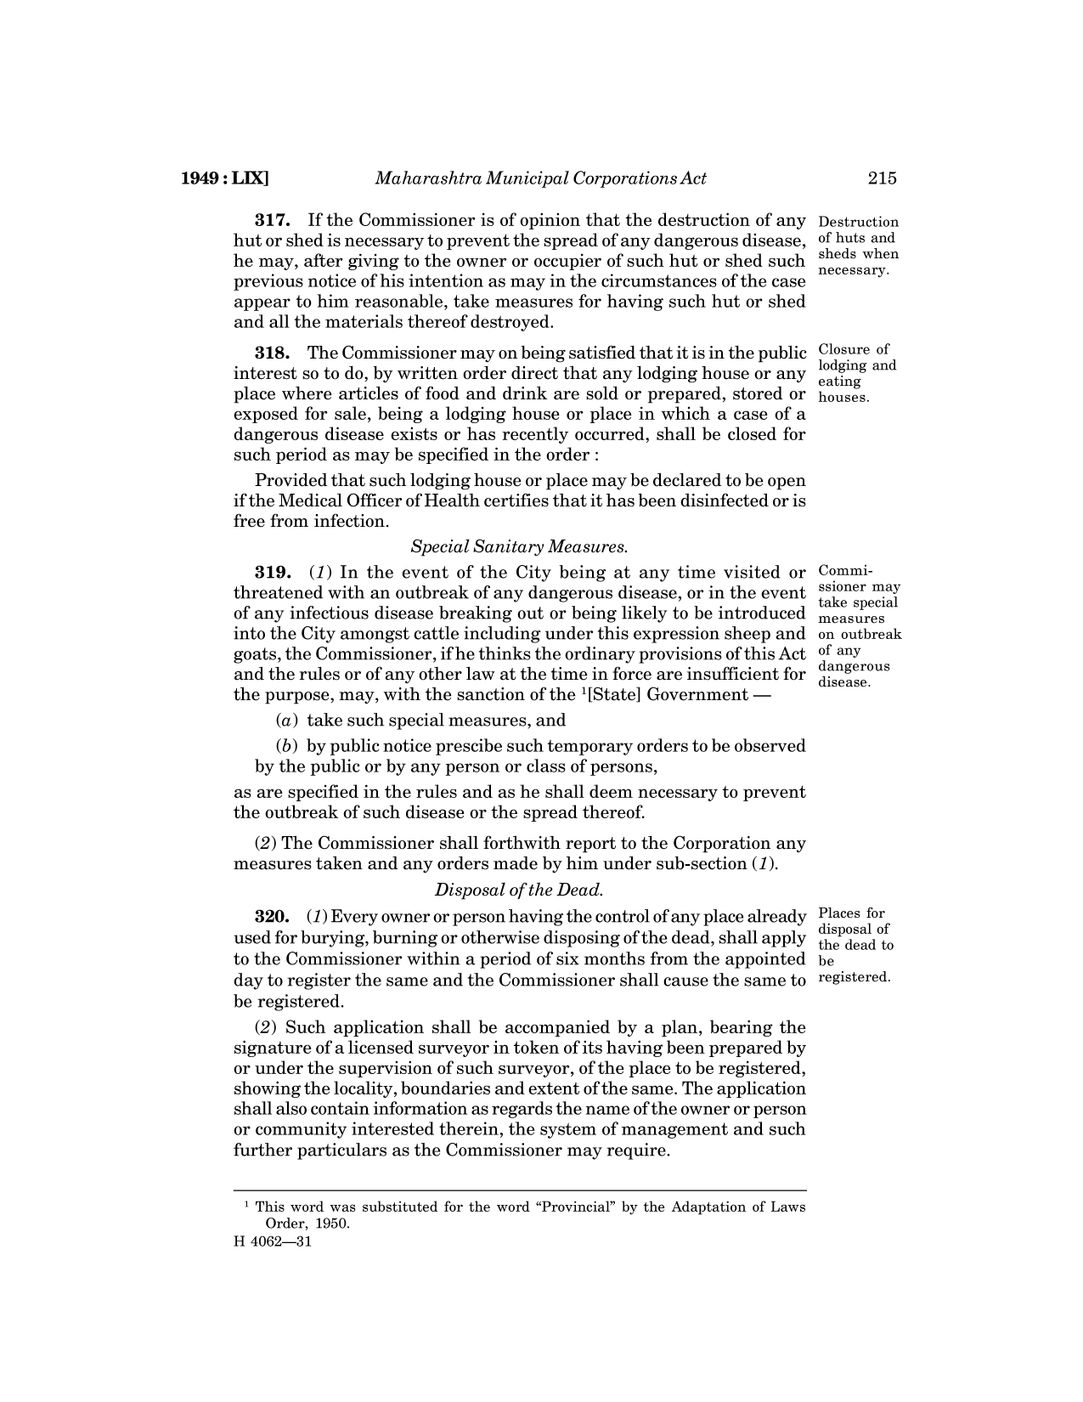

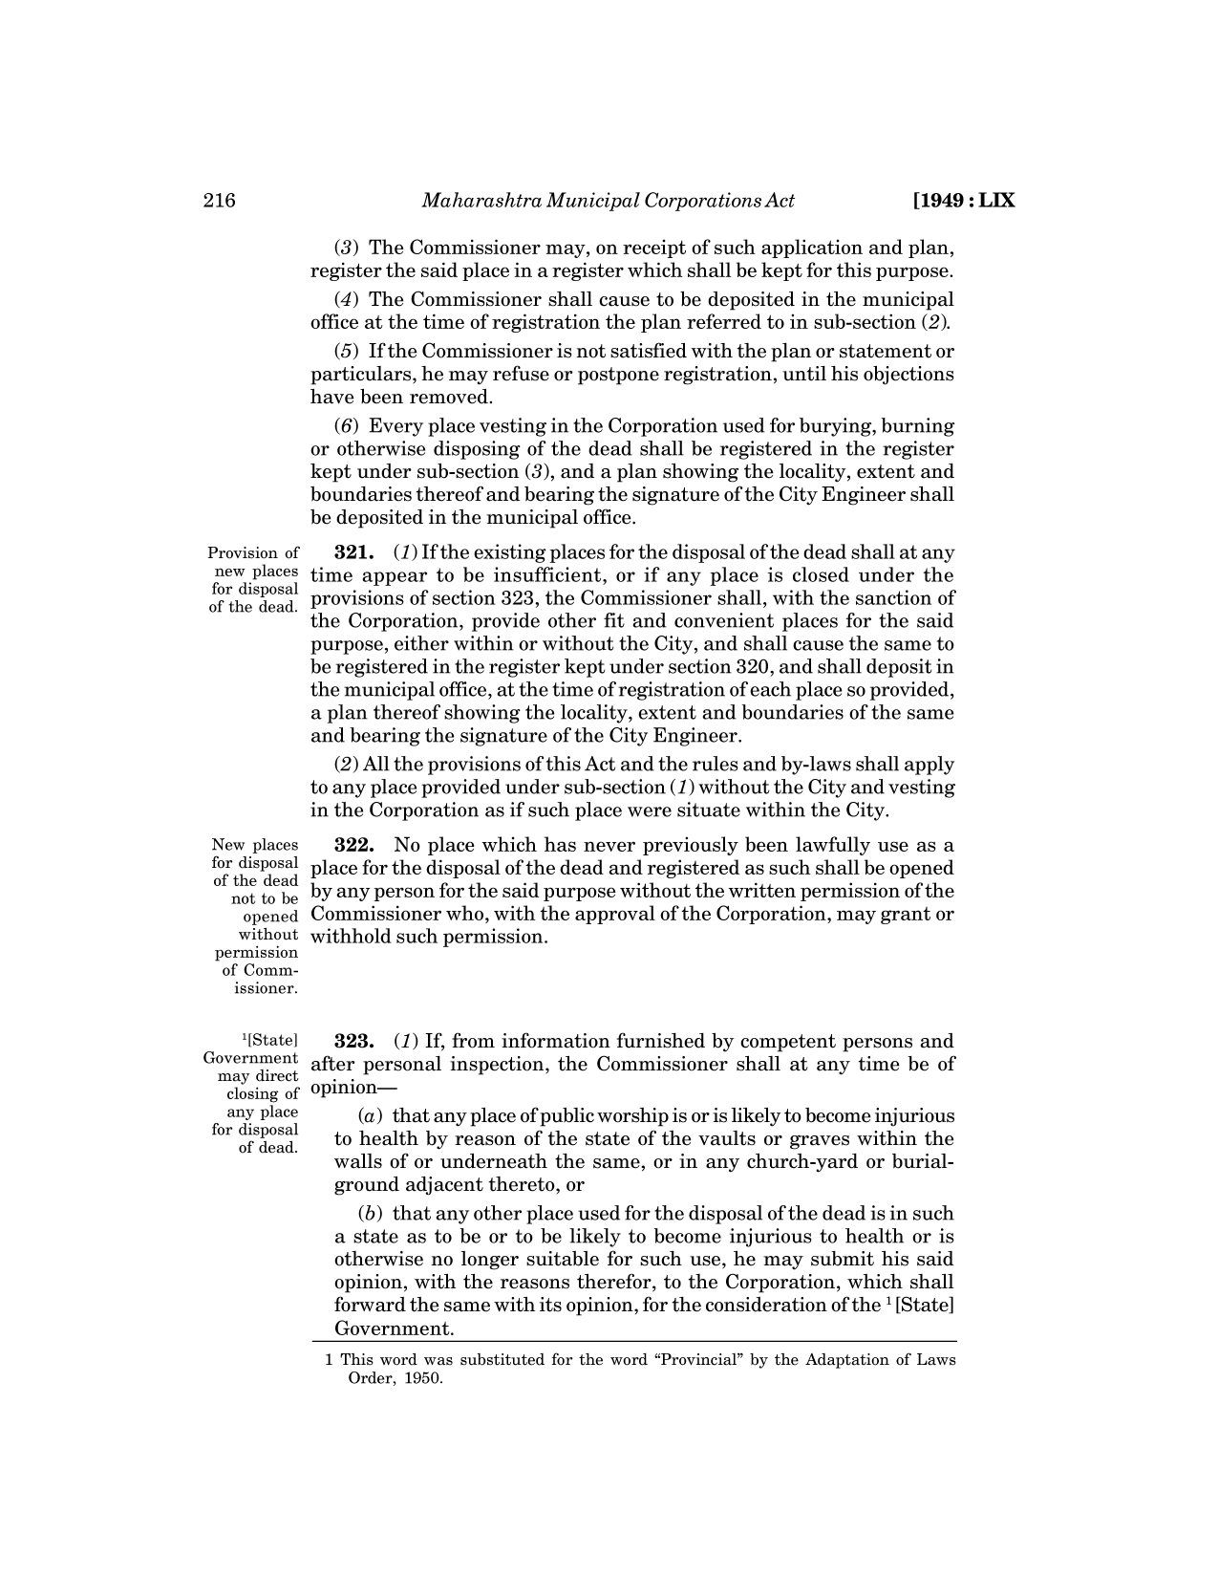

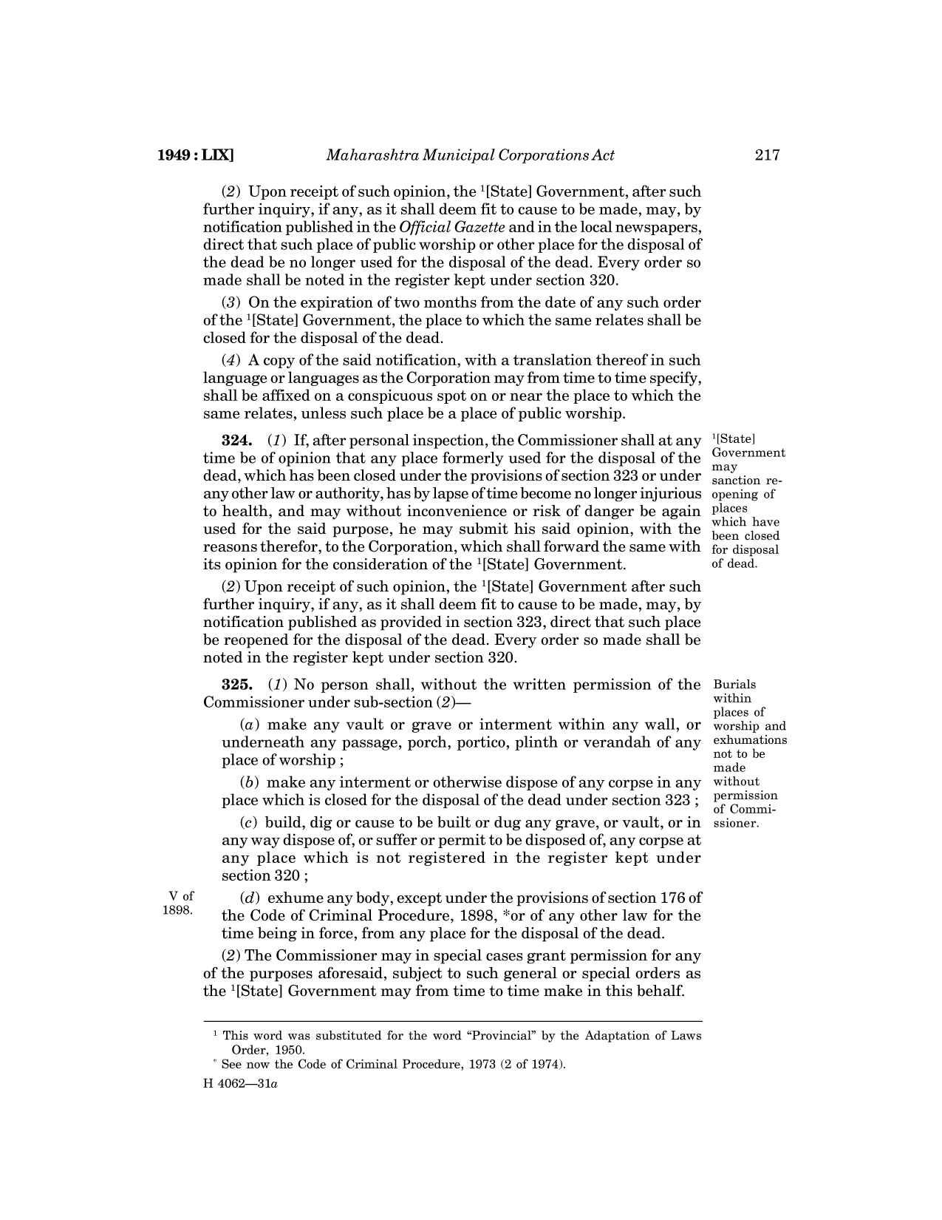

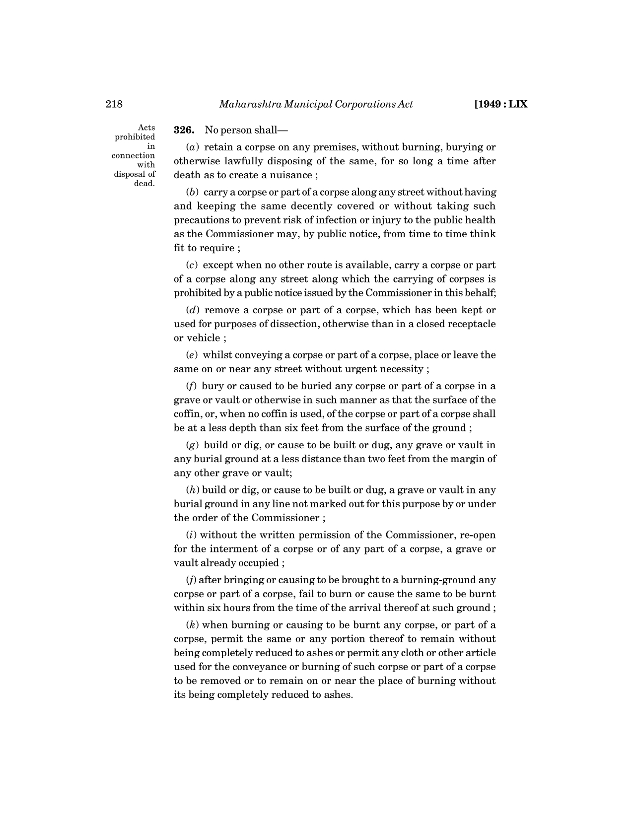

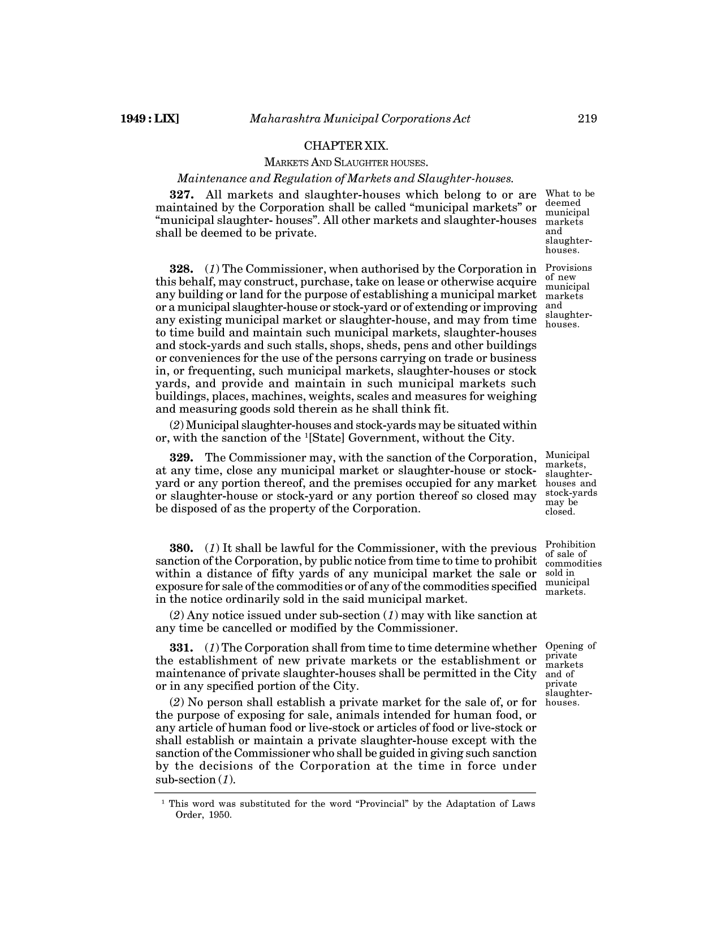

**AMC Trade Licence**

Screen Shots

* 1. Previous Approved Trade Format :

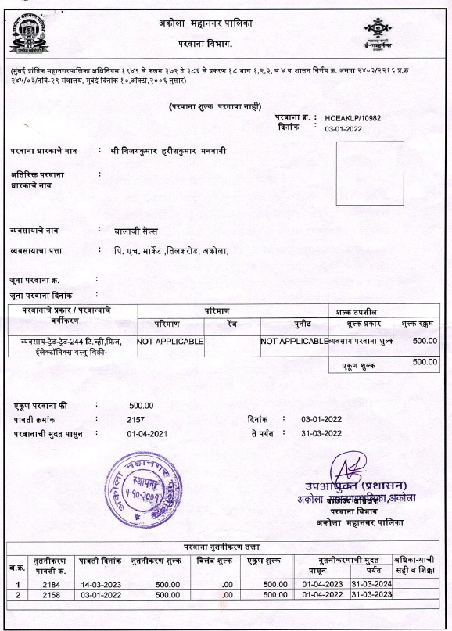

* 1. **Current Approved Trade Licence Format**

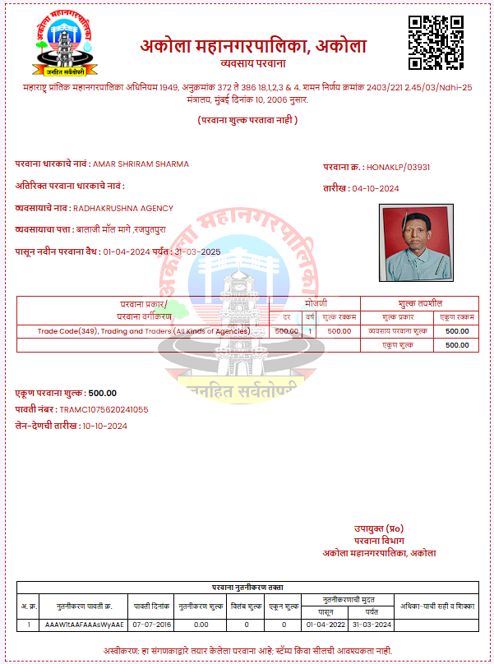

* 1. **Current Approved Trade Licence Terms and Conditions**

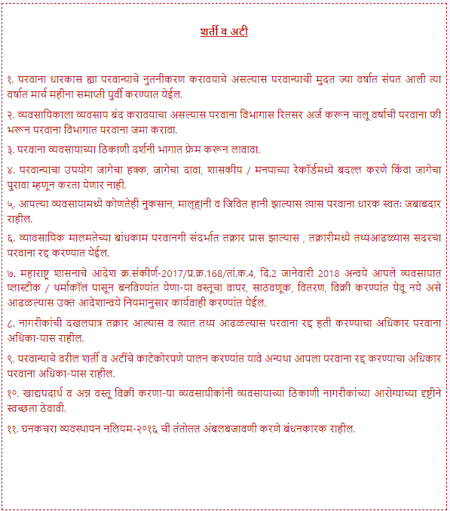

* 1. **Payment Receipt of Trade Licence**

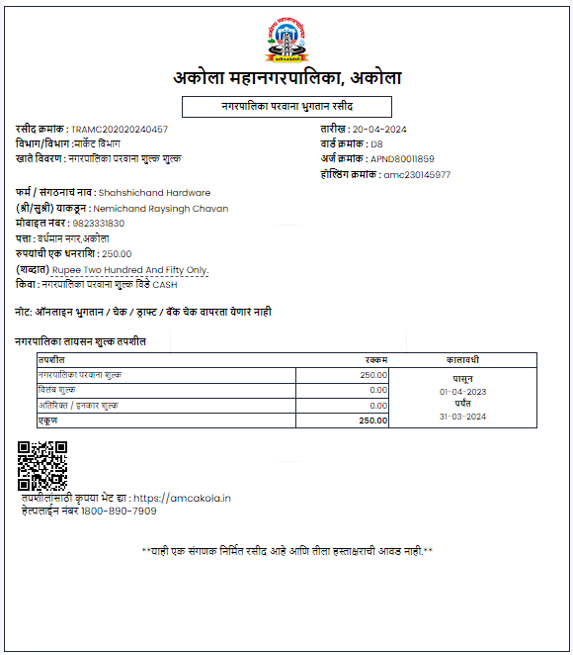

* 1. **Trade Rate Chart**

|  |  |  |  |  |  |  |  |
| --- | --- | --- | --- | --- | --- | --- | --- |
| **UNIQU KEY** (please not change) | Items | tradeCode | Old rate **(₹)** | **Provided by Sachin 22-12-2023 (On Live Server)** | **new rate 22-12-23** | **Provided by Manoj (21-05-24)** | **new rate 21-05-24** |
| 1 | Coconut rope | 1 | 250 | नारळाची दोरी | 500 | **नारळाची दोरी** | **500** |
| 2 | Jute and twine | 2 | 100 | ताग व सुतळी | 200 | **ताग व सुतळी** | **200** |
| 3 | Grass | 3 | 200 | गवत | 400 | **गवत** | **400** |
| 4 | Hey | 4 | 200 | हे (HAY) तनस | 400 | **हे (HAY) तनस** | **400** |
| 5 | Gather | 5 | 250 | जुट | 500 | **जुट** | **500** |
| 6 | knitted cloth and bags made from knitted cloth | 6 | 200 | गोणी कापड व गोणी कापडापासुन तयार केलेली पिशवी | 400 | **गोणी कापड व गोणी कापडापासुन तयार केलेली पिशवी** | **400** |
| 7 | Animal skin dry or wet | 7 | 300 | जनावराची कातडी सुकी किंवा ओली | 600 | **जनावराची कातडी सुकी किंवा ओली** | **600** |
| 8 | All kinds of jut | 8 | 300 | सर्व प्रकारची जुट | 600 | **सर्व प्रकारची जुट** | **600** |
| 9 | Making wooden boxes and finished boxes | 9 | 100 | लाकडी खोके तयार करणे व तयार खोके | 200 | **लाकडी खोके तयार करणे व तयार खोके** | **200** |
| 10 | Sandal wood / powder | 10 | 500 | चंदनाचे लाकुड/ पावडर | 1000 | **चंदनाचे लाकुड/ पावडर** | **1000** |
| 11 | Leather | 11 | 400 | चामडी | 800 | **चामडी** | **800** |
| 12 | Yatni, bamboo | 12 | 250 | बल्ली, बांबु | 500 | **बल्ली, बांबु** | **500** |
| 13 | The bones | 13 | 1000 | हाडे | 600 | **हाडे** | **600** |
| 14 | Firewood (Tal) | 14 | 200 | जळाऊ लाकुड (टाल) | 400 | **जळाऊ लाकुड (टाल)** | **400** |
| 15 | Sack (of yarn) | 15 | 300 | गोणी (सुताची) | 600 | **गोणी (सुताची)** | **600** |
| 16 | Animal horns | 16 | 100 | जनावराची शिंगे | 200 | **जनावराची शिंगे** | **200** |
| 17 | Cut to size wood | 17 | 1000 | कट साईज लाकुड | 2000 | **कट साईज लाकुड** | **2000** |
| 18 | (Aluminium) German and copper traders | 18 | 200 | (ॲल्युमिनियम) जर्मन व तांब्याचे व्यवसायीक | 400 | **(ॲल्युमिनियम) जर्मन व तांब्याचे व्यवसायीक** | **400** |
| 19 | Office of Freight Business (Transport) | 19 | 1500 | माल वाहतुक व्यवसाय कार्यालय (ट्रांन्सपोर्ट) | 3000 | **माल वाहतुक व्यवसाय कार्यालय (ट्रांन्सपोर्ट)** | **3000** |
| 20 | Scrap iron and old iron articles | 20 | 500 | लोखंडी भंगार व जुन्या लोखंडी वस्तु | 1000 | **लोखंडी भंगार व जुन्या लोखंडी वस्तु** | **1000** |
| 21 | Dealer of three wheelers and four wheelers | 21 | 2500 | तीन चाकी चार चाकी वाहने विक्रेता | 5000 | **तीन चाकी चार चाकी वाहने विक्रेता** | **5000** |
| 22 | Government Warehouse and Warehouse | 22 | 3000 | शासकिय गोडाऊन व वेअर हाऊस | 6000 | **शासकिय गोडाऊन व वेअर हाऊस** | **6000** |
| 23 | Private sweet | 23 | 500 | खाजगी गोडाऊन | 1000 | **खाजगी गोडाऊन** | **1000** |
| 24 | Textile business | 24 | 300 | कापड व्यवसाय | 300 | **कापड व्यवसाय** | **300** |
| 25 | Cement Sellers | 25 | 300 | सिमेंट विक्रेते | 600 | **सिमेंट विक्रेते** | **600** |
| 26 | All types of furniture made from wood and iron | 26 | 700 | सर्व प्रकारचे फर्निचर लाकुड व लोखंडा पासुन तयार केलेले | 1400 | **सर्व प्रकारचे फर्निचर लाकुड व लोखंडा पासुन तयार केलेले** | **1400** |
| 27 | Cement and iron roofing sheets | 27 | 500 | सिमेंट व लोखंडाचे छताचे पत्रे विक्रेते | 1000 | **सिमेंट व लोखंडाचे छताचे पत्रे विक्रेते** | **1000** |
| 28 | Dealers in computers and computer accessories and stationery | 28 | 500 | संगणक व संगणकीय वस्तु व स्टेशनरी विक्रेते | 500 | **संगणक व संगणकीय वस्तु व स्टेशनरी विक्रेते** | **500** |
| 29 | Ice cream seller | 29 | 200 | आईस्क्रीम विक्रेते | 200 | **आईस्क्रीम विक्रेते** | **200** |
| 30 | Bakery Food Vendors | 30 | 300 | बेकरीचे खादय वस्तु विक्रेते | 300 | **बेकरीचे खादय वस्तु विक्रेते** | **300** |
| 31 | Presentation / Gift Articles and Novelty Items Vendors | 31 | 300 | प्रेंझेन्ट / गीफ्ट आर्टीकल व नाविन्यपुर्ण वस्तु विक्रेते | 300 | **प्रेंझेन्ट / गीफ्ट आर्टीकल व नाविन्यपुर्ण वस्तु विक्रेते** | **300** |
| 32 | Greeting cards | 32 | 300 | शुभेच्छा देण्याचे पत्रके | 300 | **शुभेच्छा देण्याचे पत्रके** | **300** |
| 33 | Plastic goods manufacturing industry | 33 | 500 | प्लास्टीक वस्तु तयार करणारा उद्योग | 500 | **प्लास्टीक वस्तु तयार करणारा उद्योग** | **500** |
| 34 | Decorative wall paper | 34 | 200 | भिंतीवर लावण्याचे शोभेचे कागद | 200 | **भिंतीवर लावण्याचे शोभेचे कागद** | **200** |
| 35 | SANMAICA PLYWOOD AND PLYWOOD DOOR MATERIALS | 35 | 700 | सन्माईका प्लायवुड पासुन तयार केलेले दरवाजे व साहीत्य | 700 | **सन्माईका प्लायवुड पासुन तयार केलेले दरवाजे व साहीत्य** | **700** |
| 36 | GRENITE AND MARBLE STONES, TILES, MARBLE VENDORS | 36 | 700 | गिरेनाईट स संगमवरी दगड, मारबल विक्रेते | 700 | **गिरेनाईट स संगमवरी दगड, मारबल विक्रेते** | **700** |
| 37 | Candle manufacturers | 37 | 100 | मेणबत्ती उत्पादक | 100 | **मेणबत्ती उत्पादक** | **100** |
| 38 | Saavn makers | 38 | 500 | साबन निर्माते | 500 | **साबन निर्माते** | **500** |
| 39 | Mothe Dal Mill, Oil Mill, Factory, Mills, Workshop, Pharmaceutical Factory | 39 | 200 | मोठे दाल मिल, आईल मि, कारखाने, मिल्स,वर्कशॉप, औषधी निर्माण करणारा कारखाना | 2000 | **मोठे दाल मिल, आईल मि, कारखाने, मिल्स,वर्कशॉप, औषधी निर्माण करणारा कारखाना** | **2000** |
| 40 | Machine printing and dyeing | 40 | 100 | मशिनव्दारे कापडावर नक्शी कामाचे छपाई करणे रंगणे | 100 | **मशिनव्दारे कापडावर नक्शी कामाचे छपाई करणे रंगणे** | **100** |
| 41 | Bakery industry | 41 | 500 | बेकरी कारखाना | 500 | **बेकरी कारखाना** | **500** |
| 42 | Ice factory | 42 | 500 | बर्फ कारखाना | 500 | **बर्फ कारखाना** | **500** |
| 43 | Preparation of powder by processing bones and moonshine. (Oli / Suki) | 43 | 500 | हाडे व चांबडे यांच्यावर प्रक्रिया करुन पावडर तयार करणे. (ओली / सुकी) | 500 | **हाडे व चांबडे यांच्यावर प्रक्रिया करुन पावडर तयार करणे. (ओली / सुकी)** | **500** |
| 44 | Oil Ghani | 44 | 200 | तेल घानी | 200 | **तेल घानी** | **200** |
| 45 | Kandap Machine (Turmeric, Chilli, Spices, etc.) | 45 | 100 | कांडप मशिन (हळद, मिरची, मसाले, इ.) | 100 | **कांडप मशिन (हळद, मिरची, मसाले, इ.)** | **100** |
| 46 | Small Factory | 46 | 500 | छोटे कारखाने | 500 | **छोटे कारखाने** | **500** |
| 47 | Departmental Stores | 47 | 1000 | डिपार्टमेंटल स्टोअर्स | 1000 | **डिपार्टमेंटल स्टोअर्स** | **1000** |
| 48 | Readymade Garments Shop | 48 | 500 | रेडीमेड वस्त्र दुकान | 300 | **रेडीमेड वस्त्र दुकान** | **300** |
| 49 | Metal Fabrication | 49 | 500 | धातुची वस्तु तयार करणे | 500 | **धातुची वस्तु तयार करणे** | **500** |
| 50 | Gold, Silver, and Jewelry Shop | 50 | 500 | सोने, चांदी व हिऱ्याचे दुकान | 500 | **सोने, चांदी व हिऱ्याचे दुकान** | **500** |
| 51 | Showroom | 50 . A | 1000 | अ) शोरुम | 1000 | **अ) शोरुम** | **1000** |
| 52 | Hair Salon | 51 | 100 | केश कर्तनालय | 100 | **केश कर्तनालय** | **100** |
| 53 | All Electronics Repair | 52 | 200 | सर्व इलेक्ट्रानिक्स वस्तु दुरुस्ती करणे | 200 | **सर्व इलेक्ट्रानिक्स वस्तु दुरुस्ती करणे** | **200** |
| 54 | Book Binding | 53 | 100 | बुक बाईन्डींग | 100 | **बुक बाईन्डींग** | **100** |
| 55 | Factory to Manufacture Bidi and Cigarette | 54 | 1000 | बिडी व सिग्रेट तयार करणारा कारखाना | 1000 | **बिडी व सिग्रेट तयार करणारा कारखाना** | **1000** |
| 56 | Bone Factory | 55 | 1000 | हाडांचा कारखाना | 1000 | **हाडांचा कारखाना** | **1000** |
| 57 | Paper Industry (Notebook Making) | 56 | 1000 | पेपर उद्योग (नोटबुक तयार करणे) | 1000 | **पेपर उद्योग (नोटबुक तयार करणे)** | **1000** |
| 58 | Powder Mill (Talcum) | 57 | 1000 | पाडर कारखाना (Talcom) | 1000 | **पाडर कारखाना (Talcom)** | **1000** |
| 59 | Lathe Machine Planish Machine | 58 | 200 | लेथ मशिन प्लालीश मशीन | 200 | **लेथ मशिन प्लालीश मशीन** | **200** |
| 60 | Printing Press | 59 | 300 | प्रिटींग प्रेस | 300 | **प्रिटींग प्रेस** | **300** |
| 61 | Tailoring Shop (Rastyavali Sodun) | 60 | 100 | टेलरींग शॉप (रस्त्यावरील सोडून) | 100 | **टेलरींग शॉप (रस्त्यावरील सोडून)** | **100** |
| 62 | Typing Lessons | 61 | 100 | टंकलेखन शिक्षण वर्ग | 100 | **टंकलेखन शिक्षण वर्ग** | **100** |
| 63 | Taxis, Cars, Buses, Trucks, Contract-Based Vehicles, Goods Carriages, or Migrant Vehicles Owner / Organization | 62 | 500 | टॅक्सी, कार, बस, ट्रक, करारावर आधारीत वाहने माल वाहतूक किंवा प्रवासी वाहन नेण्याकरीता वापरात येणाऱ्या मालक / संस्था | 500 | **टॅक्सी, कार, बस, ट्रक, करारावर आधारीत वाहने माल वाहतूक किंवा प्रवासी वाहन नेण्याकरीता वापरात येणाऱ्या मालक / संस्था** | **500** |
| 64 | Janvarache Gothyavdare Milk Sale | 63 | 500 | जनावराचे गोठयाव्दारे दुध विक्री | 500 | **जनावराचे गोठयाव्दारे दुध विक्री** | **500** |
| 65 | Poultry Business | 64 | 400 | कुकुट पालन व्यवसाय | 500 | **कुकुट पालन व्यवसाय** | **500** |
| 66 | Photo Color Lab | 65 | 400 | फोटो कलर लॅब | 500 | **फोटो कलर लॅब** | **500** |
| 67 | Sugar Factory | 66 | 1000 | साखर कारखाने | 1000 | **साखर कारखाने** | **1000** |
| 68 | Coaching Classes (Up to 100 Students) | 67 | 500 | कोचींग क्लासेस (100 विद्यार्थ्यापर्यंत) | 500 | **कोचींग क्लासेस (100 विद्यार्थ्यापर्यंत)** | **500** |
| 69 | 101 Students to 200 Students | 67 . A | 1000 | अ) 101 विद्यार्थी ते 200 विद्यार्थ्यापर्यंत | 1000 | **अ) 101 विद्यार्थी ते 200 विद्यार्थ्यापर्यंत** | **1000** |
| 70 | From 201 students to 400 students | 67 . B | 2000 | ब) 201 विद्यार्थी ते 400 विद्यार्थ्यापर्यंत | 2000 | **ब) 201 विद्यार्थी ते 400 विद्यार्थ्यापर्यंत** | **2000** |
| 71 | From 401 students to 600 students | 67 . C | 3000 | क) 401 विद्यार्थी ते 600 विद्यार्थ्यापर्यत | 3000 | **क) 401 विद्यार्थी ते 600 विद्यार्थ्यापर्यत** | **3000** |
| 72 | From 601 students to 800 students | 67 . D | 4000 | ई) 601 विद्यार्थी ते 800 विद्यार्थ्यापर्यंत | 4000 | **ई) 601 विद्यार्थी ते 800 विद्यार्थ्यापर्यंत** | **4000** |
| 73 | From 801 students to 1000 students | 67 . E | 5000 | फ) 801 विद्यार्थी ते 1000 विद्यार्थ्यापर्यंत | 5000 | **फ) 801 विद्यार्थी ते 1000 विद्यार्थ्यापर्यंत** | **5000** |
| 74 | Over 1001 students | 67 . F | 10000 | ड) 1000 विद्यार्थ्याचे वर | 10000 | **ड) 1000 विद्यार्थ्याचे वर** | **10000** |
| 75 | Film and doordarshan training institute | 68 | 500 | चलचित्र व दुरदर्शन ट्रेनिंग संस्था | 500 | **चलचित्र व दुरदर्शन ट्रेनिंग संस्था** | **500** |
| 76 | Local Channel, (Dish Connection) | 69 | 2000 | लोकल चॅनेल (डिश कनेक्श्न) | 2000 | **लोकल चॅनेल (डिश कनेक्श्न)** | **2000** |
| 77 | Operator only | 70 | 500 | केबल ऑपरेटर | 500 | **केबल ऑपरेटर** | **500** |
| 78 | Video Center | 71 | 500 | व्हिडीओ सेंटर | 500 | **व्हिडीओ सेंटर** | **500** |
| 79 | Video Games | 72 | 500 | व्हिडीओ गेम्स | 500 | **व्हिडीओ गेम्स** | **500** |
| 80 | Cinema Home | 73 | 2000 | सिनेमा गृह | 2000 | **सिनेमा गृह** | **2000** |
| 81 | Theater | 74 | 2000 | नाटय गृह | 2000 | **नाटय गृह** | **2000** |
| 82 | Mars Office | 75 | 2000 | मंगल कार्यालय | 2000 | **मंगल कार्यालय** | **2000** |
| 83 | Social Hall and Building | 76 | 1000 | सामाजिक सभागृह व भवन | 1000 | **सामाजिक सभागृह व भवन** | **1000** |
| 84 | Lawns to be Used for Wedding Parties | 77 | 2000 | लग्न पार्टीसाठी वापरण्याचे लॉन्स | 2000 | **लग्न पार्टीसाठी वापरण्याचे लॉन्स** | **2000** |
| 85 | Dynamite | 78 | 500 | स्फोटक पदार्थ (Dynamite) | 500 | **स्फोटक पदार्थ (Dynamite)** | **500** |
| 86 | Gun Powder | 79 | 500 | गन पावडर | 500 | **गन पावडर** | **500** |
| 87 | Phosphorus / Potash | 80 | 500 | फौस्फरस / पोटॅश | 500 | **फौस्फरस / पोटॅश** | **500** |
| 88 | Dry Leaves (Patravli, Bidi Leaves) | 81 | 200 | सुके पत्ते (पत्रावळी, बिडी पाने) | 200 | **सुके पत्ते (पत्रावळी, बिडी पाने)** | **200** |
| 89 | Methylated Spirit | 82 | 200 | मेथालायटेड स्पारीट | 200 | **मेथालायटेड स्पारीट** | **200** |
| 90 | Sulphur | 83 | 200 | सल्फर | 200 | **सल्फर** | **200** |
| 91 | Potash | 84 | 200 | पोटास | 200 | **पोटास** | **200** |
| 92 | Asphalt | 85 | 1000 | डाम्बर | 1000 | **डाम्बर** | **1000** |
| 93 | Agricultural Service Centre | 86 | 500 | कृषी सेवा केंद्र | 500 | **कृषी सेवा केंद्र** | **500** |
| 94 | Color Paints, Wallpaper, Sandpaper, Varnish, and Coloring Materials | 87 | 500 | कलर पेंटस्, वॉलपेपर, सँड पेपर, वारनिश व कलर करण्याचे साहित्य | 500 | **कलर पेंटस्, वॉलपेपर, सँड पेपर, वारनिश व कलर करण्याचे साहित्य** | **500** |
| 95 | Photon | 88 | 2000 | कॉटन | 2000 | **कॉटन** | **2000** |
| 96 | West Photon | 89 | 1000 | वेस्ट कॉटन | 1000 | **वेस्ट कॉटन** | **1000** |
| 97 | Scrap Dealer | 90 | 500 | रद्दी विक्रेता ठोक विक्रेता | 500 | **रद्दी विक्रेता ठोक विक्रेता** | **500** |
| 98 | Chiller Seller | 91 | 200 | रद्दी विक्रेता चिलर विक्रेता | 200 | **रद्दी विक्रेता चिलर विक्रेता** | **200** |
| 99 | Diesel Sales Pump | 92 | 1000 | डिझेल विक्री पंप | 1000 | **डिझेल विक्री पंप** | **1000** |
| 100 | Diesel and Petrol Sales Pumps | 93 | 1500 | डिझेल व पेट्रोल विक्री पंप | 1500 | **डिझेल व पेट्रोल विक्री पंप** | **1500** |
| 101 | Oil Seed | 94 | 200 | तेल बिया | 200 | **तेल बिया** | **200** |
| 102 | Refinetine | 95 | 200 | टरफिनटाईन | 200 | **टरफिनटाईन** | **200** |
| 103 | Cinematography Films | 96 | 200 | सिनेमाटोग्राफी फिल्म्स | 200 | **सिनेमाटोग्राफी फिल्म्स** | **200** |
| 104 | Anacetateline Gas | 97 | 200 | अंसेसेटेलीन गॅस | 200 | **अंसेसेटेलीन गॅस** | **200** |
| 105 | Ash | 98 | 200 | राख | 200 | **राख** | **200** |
| 106 | Firecracker Shop Thok Sellers | 99 | 500 | फटाक्याचे दुकान ठोक विक्रेते | 500 | **फटाक्याचे दुकान ठोक विक्रेते** | **500** |
| 107 | Firecracker Shop Chiller Sellers | 100 | 200 | फटाक्याचे दुकान चिल्लर विक्रेते | 200 | **फटाक्याचे दुकान चिल्लर विक्रेते** | **200** |
| 108 | Hawker | 101 | 500 | कोळसा | 500 | **कोळसा** | **500** |
| 109 | Mutton / Chicken Sale | 102 | 200 | मटन / चिकन विक्री | 200 | **मटन / चिकन विक्री** | **200** |
| 110 | Happy Fish Sales | 103 | 100 | सुखी मासळी विक्री | 100 | **सुखी मासळी विक्री** | **100** |
| 111 | Manufacturing as well as Selling and Packing Ghee | 104 | 300 | तुप तयार करणे तसेच विकणे व पॅक करणे | 300 | **तुप तयार करणे तसेच विकणे व पॅक करणे** | **300** |
| 112 | Types of Wells, Cold Drinks, Mineral Water | 105 | 1000 | विव्हिरेल प्रकार, थंड पेय, मिनरल वॉटर | 1000 | **विव्हिरेल प्रकार, थंड पेय, मिनरल वॉटर** | **1000** |
| 113 | Bricks, and Tiles (Handmade) | 106 | 500 | विटा व टाईल्स (हाताने बनविणे) | 500 | **विटा व टाईल्स (हाताने बनविणे)** | **500** |
| 114 | Pottery | 107 | 100 | Pottery (मातीची भांडी) | 100 | **Pottery (मातीची भांडी)** | **100** |
| 115 | Gas Agencies and Sellers | 108 | 500 | गॅस एजंन्सी व विक्रेते | 500 | **गॅस एजंन्सी व विक्रेते** | **500** |
| 116 | Grocers | 109 | 1000 | किराणा ठोक विक्रेते | 500 | **किराणा ठोक विक्रेते** | **500** |
| 117 | Grocer Chivar Sellers | 110 | 200 | किराणा चिल्लर विक्रेते | 200 | **किराणा चिल्लर विक्रेते** | **200** |
| 118 | General Stores / Cutlery | 111 | 200 | जनरल स्टोअर्स / कटलरी | 200 | **जनरल स्टोअर्स / कटलरी** | **200** |
| 119 | In Stationery | 112 | 200 | स्टेशनरी मार्ट | 300 | **स्टेशनरी मार्ट** | **300** |
| 120 | Adat Shopkeeper and Commission Agent | 113 | 400 | अडत दुकानदार व कमीशन एजंट | 400 | **अडत दुकानदार व कमीशन एजंट** | **400** |
| 121 | Book Sellers / Magazine Center | 114 | 100 | बुक सेलर्स / मॅगझीन सेंटर | 100 | **बुक सेलर्स / मॅगझीन सेंटर** | **100** |
| 122 | Drug Dealers, Street Vendors | 115 | 1000 | औषधी विक्रते ठेाक विक्रेते | 1000 | **औषधी विक्रते ठेाक विक्रेते** | **1000** |
| 123 | Medicine Dealers (Allopathy & Ayurvedic) Chiller Dealers | 116 | 500 | औषधी विक्रेते (ॲलोपॅथी व आयुर्वेदीक) चिल्लर विक्रेते | 500 | **औषधी विक्रेते (ॲलोपॅथी व आयुर्वेदीक) चिल्लर विक्रेते** | **500** |
| 124 | Tea and Coffee, Street Vendors | 117 | 300 | चहा आणि कॉफी ठोक विक्रेते | 300 | **चहा आणि कॉफी ठोक विक्रेते** | **300** |
| 125 | Tea and Coffee Chiller Dealers | 118 | 100 | चहा आणि कॉफी चिल्लर विक्रेते | 100 | **चहा आणि कॉफी चिल्लर विक्रेते** | **100** |
| 126 | Bhajipala | 119 | 100 | भाजीपाला | 100 | **भाजीपाला** | **100** |
| 127 | Silk / Zari | 120 | 100 | सिल्क / जरी | 100 | **सिल्क / जरी** | **100** |
| 128 | Maniyari Articles, Street Vendors | 121 | 300 | मनियारी आर्टीकल्स ठोक विक्रेते | 300 | **मनियारी आर्टीकल्स ठोक विक्रेते** | **300** |
| 129 | Maniyari Articles Chiller Dealers | 122 | 100 | मनियारी आर्टीकल्स चिल्लर विक्रेते | 100 | **मनियारी आर्टीकल्स चिल्लर विक्रेते** | **100** |
| 130 | Fruits (Contains Coconut), Street Vendors | 123 | 200 | फळे (समाविष्ठ नारळ) ठोक विक्रेते | 200 | **फळे (समाविष्ठ नारळ) ठोक विक्रेते** | **200** |
| 131 | Fruits (Contains Coconut) Chiller Dealers | 124 | 100 | फळे (समाविष्ठ नारळ) चिल्लर विक्रेते | 100 | **फळे (समाविष्ठ नारळ) चिल्लर विक्रेते** | **100** |
| 132 | Onion, Dried Chilli, Garlic, Street Vendors | 125 | 200 | कांदे, सुकी मिर्ची, लसन ठोक विक्रेते | 200 | **कांदे, सुकी मिर्ची, लसन ठोक विक्रेते** | **200** |
| 133 | Onion, Dried Chilli, Garlic Chiller Dealers | 126 | 100 | कांदे, सुकी मिर्ची, लसन ठोक विक्रेते | 100 | **कांदे, सुकी मिर्ची, लसन ठोक विक्रेते** | **100** |
| 134 | Jaggery, Sugar, Street Vendors | 127 | 1000 | गुड, साखर ठोक विक्रेते | 1000 | **गुड, साखर ठोक विक्रेते** | **1000** |
| 135 | Jaggery, Sugar Chiller Dealers | 128 | 200 | गुड, साखर चिल्लर विक्रेते | 200 | **गुड, साखर चिल्लर विक्रेते** | **200** |
| 136 | Hardware, Street Vendors | 129 | 1000 | हार्डवेअर ठोक विक्रेते | 1000 | **हार्डवेअर ठोक विक्रेते** | **1000** |
| 137 | Hardware Chiller Dealers | 130 | 250 | हार्डवेअर चिल्लर विक्रेते | 250 | **हार्डवेअर चिल्लर विक्रेते** | **250** |
| 138 | Betel Leaves Chiller Dealers | 131 | 200 | पान पत्ते ठोक विक्रेते | 200 | **पान पत्ते ठोक विक्रेते** | **200** |
| 139 | Betel Leaves, Street Vendors | 132 | 100 | पान पत्ते चिल्लर विक्रेते | 100 | **पान पत्ते चिल्लर विक्रेते** | **100** |
| 140 | Egg Seller | 133 | 200 | अंडे विक्रेते | 200 | **अंडे विक्रेते** | **200** |
| 141 | Hosiery Goods Chiller Dealers | 134 | 1000 | होजीयरी गुडस् ठोक विक्रेते | 500 | **होजीयरी गुडस् ठोक विक्रेते** | **500** |
| 142 | Hosiery Goods, Street Vendors | 135 | 210 | होजीयरी गुडस् चिल्लर विक्रेते | 210 | **होजीयरी गुडस् चिल्लर विक्रेते** | **210** |
| 143 | Automobile Shop | 136 | 500 | ऑटोमोबाईलचे दुकान | 500 | **ऑटोमोबाईलचे दुकान** | **500** |
| 144 | Bangdya | 137 | 100 | बांगडया | 100 | **बांगडया** | **100** |
| 145 | Homeopathy Drug Sales | 138 | 250 | होमीओपॅथी औषध विक्री | 250 | **होमीओपॅथी औषध विक्री** | **250** |
| 146 | Tobacco, Street Vendors | 139 | 250 | तंबाखु ठोक विक्रेते | 250 | **तंबाखु ठोक विक्रेते** | **250** |
| 147 | Tobacco, Picture Sellers | 140 | 100 | तंबाखु चिल्लर विक्रेते | 100 | **तंबाखु चिल्लर विक्रेते** | **100** |
| 148 | Panpatti Shop | 141 | 100 | पानपट्टी दुकान | 100 | **पानपट्टी दुकान** | **100** |
| 149 | Plastic Item Chiller Dealers | 142 | 100 | प्लॅस्टीक वस्तु चिल्लर विक्री | 100 | **प्लॅस्टीक वस्तु चिल्लर विक्री** | **100** |
| 150 | Making Ice Fruit Factory (By Machine) (Ice Candy) | 143 | 200 | धान्य दुकान (रेशन शॉप) | 200 | **धान्य दुकान (रेशन शॉप)** | **200** |
| 151 | Ration Shop | 144 | 200 | आईसफ्रुट कारखाना (मशीनव्दारे) आईस कांडी तयार करणे | 200 | **आईसफ्रुट कारखाना (मशीनव्दारे) आईस कांडी तयार करणे** | **200** |
| 152 | Preparing Ice Cream Kulfi Hatavdare | 145 | 100 | आईस्क्रीम कुल्फी हाताव्दारे तयार करणे | 100 | **आईस्क्रीम कुल्फी हाताव्दारे तयार करणे** | **100** |
| 153 | Battery Charging | 146 | 200 | बॅटरी चार्जींग | 200 | **बॅटरी चार्जींग** | **200** |
| 154 | Nickel Plating | 147 | 100 | निक्कल प्लेन्टींग | 100 | **निक्कल प्लेन्टींग** | **100** |
| 155 | Electric Welding | 148 | 500 | विद्युत वेल्डींग | 500 | **विद्युत वेल्डींग** | **500** |
| 156 | Pitachi Girni | 149 | 100 | पिठाची गिरणी | 100 | **पिठाची गिरणी** | **100** |
| 157 | Temporary Entertainment | 150 | 500 | तात्पुरते मनोरंजन | 500 | **तात्पुरते मनोरंजन** | **500** |
| 158 | Bicycle Stand | 151 | 100 | सायकल स्टँड | 100 | **सायकल स्टँड** | **100** |
| 159 | Carpenter's Shop | 152 | 200 | सुतार कामाचे दुकान | 200 | **सुतार कामाचे दुकान** | **200** |
| 160 | Dance School | 153 | 200 | नृत्य शाळा | 200 | **नृत्य शाळा** | **200** |
| 161 | Puncture Removal Business (Horse Power) | 154 | 100 | पंचर काढण्याचे व्यवसाय (अश्रवशक्तीव्दारे) | 100 | **पंचर काढण्याचे व्यवसाय (अश्रवशक्तीव्दारे)** | **100** |
| 162 | Cycle Repairs & Cycle Rentals | 155 | 100 | सायकल रिपेअर्स व सायकल भाडयाने देणे | 100 | **सायकल रिपेअर्स व सायकल भाडयाने देणे** | **100** |
| 163 | Motor Vehicle Servicing Center | 156 | 200 | मोटार वाहन सर्व्हीसींग सेंटर | 200 | **मोटार वाहन सर्व्हीसींग सेंटर** | **200** |
| 164 | Earthen Post | 157 | 100 | Earthen Post | 100 | **Earthen Post** | **100** |
| 165 | Engraving | 158 | 100 | Engraving (कोरीव काम) | 100 | **Engraving (कोरीव काम)** | **100** |
| 166 | Photo Framing | 159 | 100 | फोटो फ्रेमींग | 100 | **फोटो फ्रेमींग** | **100** |
| 167 | Puff Shop | 160 | 100 | फुलाचे दुकान | 100 | **फुलाचे दुकान** | **100** |
| 168 | Gold and Silver Polish | 161 | 50 | सोने, चांदी पॉलीस देणारे | 50 | **सोने, चांदी पॉलीस देणारे** | **50** |
| 169 | Gramophone, Tape Recorder, Radio Repair and Sales | 162 | 200 | ग्रोमोफोन, टेपरेकार्डर, रेडीयो दुरुस्ती व विक्री | 200 | **ग्रोमोफोन, टेपरेकार्डर, रेडीयो दुरुस्ती व विक्री** | **200** |
| 170 | Music Literature Repair and Sales Shop | 163 | 200 | संगीत साहित्य दुरुस्ती व विक्रीचे दुकान | 200 | **संगीत साहित्य दुरुस्ती व विक्रीचे दुकान** | **200** |
| 171 | All Types of Machinery Sales and Service | 164 | 500 | सर्व प्रकारच्या मशनरी विक्री व सेवा | 500 | **सर्व प्रकारच्या मशनरी विक्री व सेवा** | **500** |
| 172 | Money Lenders | 165 | 500 | Money Landers | 500 | **Money Landers** | **500** |
| 173 | Money Exchange | 166 | 200 | Money Exchange | 200 | **Money Exchange** | **200** |
| 174 | Sale of Spectacles and Spectacles Literature | 167 | 200 | चष्मा व चष्माचे साहित्य विक्री | 200 | **चष्मा व चष्माचे साहित्य विक्री** | **200** |
| 175 | Sale of Counterfeit Drugs | 168 | 200 | नकली दागीणे विक्री | 200 | **नकली दागीणे विक्री** | **200** |
| 176 | Sewing Machine Shop (New) | 169 | 200 | शिलाई मशीनचे दुकान (नविन) | 200 | **शिलाई मशीनचे दुकान (नविन)** | **200** |
| 177 | Sanitary Fitting Goods | 170 | 200 | सेनेटरी फिटींग गुडस् | 200 | **सेनेटरी फिटींग गुडस्** | **200** |
| 178 | Glassware Shop | 171 | 500 | काचेच्या वस्तुचे दुकान | 500 | **काचेच्या वस्तुचे दुकान** | **500** |
| 179 | Tent House / Furniture Rental | 172 | 200 | टेन्ट हाऊस / फर्निचर भाडयाचे देणे | 200 | **टेन्ट हाऊस / फर्निचर भाडयाचे देणे** | **200** |
| 180 | Registration Cooperative Society | 173 | 200 | रजिस्ट्रेशन सहकारी संस्था | 200 | **रजिस्ट्रेशन सहकारी संस्था** | **200** |
| 181 | Garage Two Wheeler | 174 | 100 | गॅरेज टु व्हिलर | 100 | **गॅरेज टु व्हिलर** | **100** |
| 182 | Garage The Wheeler | 175 | 200 | गॅरेज थ्री व्हिलर | 200 | **गॅरेज थ्री व्हिलर** | **200** |
| 183 | Bank / L.I.C. | 176 | 2000 | बॅँक / एल.आय.सी. | 2000 | **बॅँक / एल.आय.सी.** | **2000** |
| 184 | Address Agency | 177 | 500 | पत संस्था | 500 | **पत संस्था** | **500** |
| 185 | Play Material | 178 | 200 | खेळण्याचे साहित्य | 200 | **खेळण्याचे साहित्य** | **200** |
| 186 | Floor and Tile Shop | 179 | 500 | फरशी व कडप्‍याचे दुकान | 500 | **फरशी व कडप्‍याचे दुकान** | **500** |
| 187 | Junya Second Hand Store | 180 | 250 | जुन्या वापरलेल्या वस्तुचे दुकान | 250 | **जुन्या वापरलेल्या वस्तुचे दुकान** | **250** |
| 188 | Housing Finance Institution / Chit Fund and All Types of Loan Lenders | 181 | 1000 | हाऊसींग फायनान्स संस्था / चि फंड व सर्व प्रकारचे कर्ज देणारी संस्था | 1000 | **हाऊसींग फायनान्स संस्था / चि फंड व सर्व प्रकारचे कर्ज देणारी संस्था** | **1000** |
| 189 | Watch Sales / Repair Shop | 182 | 200 | घडयाळ विक्री / दुरुस्ती दुकान | 200 | **घडयाळ विक्री / दुरुस्ती दुकान** | **200** |
| 190 | Electric Motor Repair (Rewinding) | 183 | 100 | इलेक्ट्रानिक मोटार दुरुस्ती (रिवाईडींग) | 100 | **इलेक्ट्रानिक मोटार दुरुस्ती (रिवाईडींग)** | **100** |
| 191 | Karamanukichi Jaga | 184 | 500 | करमणुकीची जागा | 500 | **करमणुकीची जागा** | **500** |
| 192 | Hawkers | 185 | 100 | फेरीवाले | 100 | **फेरीवाले** | **100** |
| 193 | Raswanti | 186 | 200 | रसवंती | 200 | **रसवंती** | **200** |
| 194 | Papad Making | 187 | 100 | पापड बनविणे | 100 | **पापड बनविणे** | **100** |
| 195 | Nursery / Rope Selling | 188 | 200 | नर्सरी / रोपविक्री | 200 | **नर्सरी / रोपविक्री** | **200** |
| 196 | Handloom Units | 189 | 500 | हॅंन्डलुम युनिटस् | 500 | **हॅंन्डलुम युनिटस्** | **500** |
| 197 | Allopathic, Homeopathic, Ayurvedic Dispensary (Dawakhana) | 190 | 300 | ॲलोपॅथिक, होमीओपॅथीक, आयुर्वेदीक डिस्पेन्सरी (दवाखाना) | 300 | **ॲलोपॅथिक, होमीओपॅथीक, आयुर्वेदीक डिस्पेन्सरी (दवाखाना)** | **300** |
| 198 | Radiologist | 191 | 300 | रेडीआलॉजीस्ट | 300 | **रेडीआलॉजीस्ट** | **300** |
| 199 | Pathological Laboratories | 192 | 300 | पॅथॅलॉजीकल लेबोरेटरीज | 300 | **पॅथॅलॉजीकल लेबोरेटरीज** | **300** |
| 200 | Make Shay | 193 | 100 | शाई बनविणे | 100 | **शाई बनविणे** | **100** |
| 201 | Gas Welding | 194 | 100 | गॅस वेल्डींग | 100 | **गॅस वेल्डींग** | **100** |
| 202 | Electric Decoration, Sound Service | 195 | 200 | इलेक्ट्रानिक डेकोरेशन, साऊंड सर्व्हिस | 200 | **इलेक्ट्रानिक डेकोरेशन, साऊंड सर्व्हिस** | **200** |
| 203 | Consulting Medical Practitioner | 196 | 200 | कन्संल्टींग मेडीकल प्रॅक्टीशनर | 200 | **कन्संल्टींग मेडीकल प्रॅक्टीशनर** | **200** |
| 204 | Hawkers (Sellers of Food and Other Goods) | 197 | 100 | फेरीवाले (अन्न व इतर वस्तु विक्रेते) | 100 | **फेरीवाले (अन्न व इतर वस्तु विक्रेते)** | **100** |
| 205 | Health Clinic | 198 | 200 | हेल्थ क्लिनिक | 200 | **हेल्थ क्लिनिक** | **200** |
| 206 | Hatigadi Var Food and Other Goods Seller (Feri Wale) | 199 | 100 | हाथगाडी वर अन्न व इतर वस्तु विक्रेता (फेरीवाले) | 100 | **हाथगाडी वर अन्न व इतर वस्तु विक्रेता (फेरीवाले)** | **100** |
| 207 | Public Place Tourism Zone Valaya, Raceclub Health Resort | 200 | 500 | सार्वजनिक ठिकाणी पर्यटन क्षेत्रात क्लब, रेसक्लब हेल्थ रिसोर्ट | 500 | **सार्वजनिक ठिकाणी पर्यटन क्षेत्रात क्लब, रेसक्लब हेल्थ रिसोर्ट** | **500** |
| 208 | Photocopying (Xerox) | 201 | 100 | छायायप्रत काढणे (झेरॉक्स) | 100 | **छायायप्रत काढणे (झेरॉक्स)** | **100** |
| 209 | Video Sathi Library | 202 | 200 | व्हिडीओसाठी लायब्ररी | 200 | **व्हिडीओसाठी लायब्ररी** | **200** |
| 210 | New Books / Magazines Seller | 203 | 200 | निविन पुस्तके / मासिक विक्रेते | 200 | **निविन पुस्तके / मासिक विक्रेते** | **200** |
| 211 | June Book Sellers | 204 | 100 | जुने पुस्तके विक्रेते | 100 | **जुने पुस्तके विक्रेते** | **100** |
| 212 | Beauty Parlor | 205 | 200 | ब्युटी पार्लर | 200 | **ब्युटी पार्लर** | **200** |
| 213 | Supermarket | 206 | 1000 | सुपर मार्केट | 1000 | **सुपर मार्केट** | **1000** |
| 214 | Showroom (New and Old) | 207 | 1000 | शोरुम (नविन आणि जुने) | 1000 | **शोरुम (नविन आणि जुने)** | **1000** |
| 215 | Penachi Shop | 208 | 100 | पेनाची दुकान | 100 | **पेनाची दुकान** | **100** |
| 216 | Administrative Office | 209 | 250 | ॲडमीस्टेटीव्ह ऑफीस | 250 | **ॲडमीस्टेटीव्ह ऑफीस** | **250** |
| 217 | Karate Training Center | 210 | 200 | कराटे प्रशिक्षण केंद्र | 200 | **कराटे प्रशिक्षण केंद्र** | **200** |
| 218 | Gymnastics Training Center | 211 | 200 | जिन्मेस्टीक प्रशिक्षण केंद्र | 200 | **जिन्मेस्टीक प्रशिक्षण केंद्र** | **200** |
| 219 | Private Tuition Classes and Institutions | 212 | 500 | खाजगी शिकवणी वर्ग व संस्था | 500 | **खाजगी शिकवणी वर्ग व संस्था** | **500** |
| 220 | Grocers / All Types of Brokers (Property Distributors) | 213 | 500 | ब्रोकर्स / सर्व प्रकारचे ब्रोकर्स (संपत्ती वितरक) | 500 | **ब्रोकर्स / सर्व प्रकारचे ब्रोकर्स (संपत्ती वितरक)** | **500** |
| 221 | Pan Masala (Cigarette, Betel Nut, Gutkha, etc.) | 214 | 300 | पान मसाला (सिग्रेट, सुपारी, गुटखा) | 300 | **पान मसाला (सिग्रेट, सुपारी, गुटखा)** | **300** |
| 222 | Cooler & Air Conditioner Dealers | 215 | 200 | कुलर व एअर कंडीशनर विक्रेते | 200 | **कुलर व एअर कंडीशनर विक्रेते** | **200** |
| 223 | Crockery | 216 | 100 | काचेच्या व चिनी मातेच्या वस्तु(क्राकरी) | 100 | **काचेच्या व चिनी मातेच्या वस्तु(क्राकरी)** | **100** |
| 224 | Confessional | 217 | 200 | कन्फेश्नरी | 200 | **कन्फेश्नरी** | **200** |
| 225 | Auto Rickshaw Dealer | 218 | 200 | ऑटो रिक्षा डिलर | 200 | **ऑटो रिक्षा डिलर** | **200** |
| 226 | Auto Co-Sitter Dealer | 219 | 500 | ऑटो सहा सिटर डिलर | 500 | **ऑटो सहा सिटर डिलर** | **500** |
| 227 | Tractor Dealer | 220 | 1000 | टॅक्टर डिलर | 1000 | **टॅक्टर डिलर** | **1000** |
| 228 | Clean and Sell Kombadi Kapun | 221 | 300 | कोंबडी कापुनस्वच्छ करुन विकणे | 300 | **कोंबडी कापुनस्वच्छ करुन विकणे** | **300** |
| 229 | Toy Seller | 222 | 100 | खेळणी विक्रेता | 100 | **खेळणी विक्रेता** | **100** |
| 230 | Commission Agent / Aircraft Carrier / Railway Booking / Luxury Buses Booking | 223 | 200 | कमीशन एजंट/विमान वाहतुक/रेल्वे बुकींग/लक्झरी बसेस बुकींग चे कार्यालय | 200 | **कमीशन एजंट/विमान वाहतुक/रेल्वे बुकींग/लक्झरी बसेस बुकींग चे कार्यालय** | **200** |
| 231 | Couples / Chaplache Showroom | 224 | 500 | जोडे/ चपलाचे शोरुम | 500 | **जोडे/ चपलाचे शोरुम** | **500** |
| 232 | Pair / Chapala Handmade and Sold | 225 | 100 | जोडे / चपला हाताने तयार करुन विक्री करणे | 100 | **जोडे / चपला हाताने तयार करुन विक्री करणे** | **100** |
| 233 | Bicycle Suit Shop | 226 | 200 | सायकलच्या सुटे भागाचे दुकान | 200 | **सायकलच्या सुटे भागाचे दुकान** | **200** |
| 234 | Country Liquor Vendors | 227 | 1000 | देशी दारुचे ठोक विक्रेते | 1000 | **देशी दारुचे ठोक विक्रेते** | **1000** |
| 235 | Foreign Liquor Seller | 228 | 1000 | विदेशी दारुचे ठोक विक्रेते | 1000 | **विदेशी दारुचे ठोक विक्रेते** | **1000** |
| 236 | Country Liquor Images Seller | 229 | 500 | देशी दारुचे‍ चिल्लर विक्रेते | 500 | **देशी दारुचे‍ चिल्लर विक्रेते** | **500** |
| 237 | Foreign Daruche Chiller Sellers | 230 | 500 | विदेशी दारुचे चिल्लर विक्रेते | 500 | **विदेशी दारुचे चिल्लर विक्रेते** | **500** |
| 238 | Cloth Rental | 231 | 300 | कापडी मांडव भाडयाने देणे | 300 | **कापडी मांडव भाडयाने देणे** | **300** |
| 239 | Simple Preparation / Rear Stamp / Die Making | 232 | 100 | साचे तयार करणे/ रबर स्टॅम्प / डाई बनविणे | 100 | **साचे तयार करणे/ रबर स्टॅम्प / डाई बनविणे** | **100** |
| 240 | Courier Service | 233 | 500 | कुरीअर सर्व्हिस | 500 | **कुरीअर सर्व्हिस** | **500** |
| 241 | STD, Income SD, PCO, Fax | 234 | 210 | एस.टी.डी. , आय.एस.डी , पी.सी.ओ., फॅक्स | 210 | **एस.टी.डी. , आय.एस.डी , पी.सी.ओ., फॅक्स** | **210** |
| 242 | Exhibition Every Day, Sale of Cloth or Other Items | 235 | 200 | प्रति दिवस प्रदर्शनी लावुन काड किंवा अन्य वस्तु विक्री करणे | 200 | **प्रति दिवस प्रदर्शनी लावुन काड किंवा अन्य वस्तु विक्री करणे** | **200** |
| 243 | Commercial Hostel | 236 | 500 | व्यवसायीक हॉस्टेल | 500 | **व्यवसायीक हॉस्टेल** | **500** |
| 244 | Shops Lavun (Small Khoki Shops) Selling Various Items | 237 | 100 | दुकाने लावुन ( छोटे खोकी दुकाने) वेगवेगळया वस्तु विक्री | 100 | **दुकाने लावुन ( छोटे खोकी दुकाने) वेगवेगळया वस्तु विक्री** | **100** |
| 245 | Recognized Milk Wiki Shop | 238 | 100 | मान्यता प्राप्त दुध विक्रीचे दुकान | 100 | **मान्यता प्राप्त दुध विक्रीचे दुकान** | **100** |
| 246 | Hawkers - Solid Business | 239 | 500 | भांडे विक्रेते ठोक व्यवसायीक | 500 | **भांडे विक्रेते ठोक व्यवसायीक** | **500** |
| 247 | Hawkers - Picture Professional | 240 | 200 | भांडे विक्रेते चिल्लर व्यवसायीक | 200 | **भांडे विक्रेते चिल्लर व्यवसायीक** | **200** |
| 248 | June Tire Tube Sale / Remold | 241 | 200 | जुने टायर टयुब विक्री / रिमोल्ड | 200 | **जुने टायर टयुब विक्री / रिमोल्ड** | **200** |
| 249 | Florist | 242 | 300 | फ्लोरीस्ट | 300 | **फ्लोरीस्ट** | **300** |
| 250 | Video Pull Parlor | 243 | 200 | व्हिडीओ पुल पार्लर | 200 | **व्हिडीओ पुल पार्लर** | **200** |
| 251 | TV, Freezer, Washing Machine and Electronic Goods Sale | 244 | 500 | टि.व्ही., फ्रीज, वाशिंग मशीन व इलेक्ट्रॅानिक्स वस्तु विक्री | 500 | **टि.व्ही., फ्रीज, वाशिंग मशीन व इलेक्ट्रॅानिक्स वस्तु विक्री** | **500** |
| 252 | Book Binding | 245 | 100 | बुक बाईन्डींग | 100 | **बुक बाईन्डींग** | **100** |
| 253 | Fish Aquariums | 246 | 200 | फीश एक्वारीयंम्स | 200 | **फीश एक्वारीयंम्स** | **200** |
| 254 | Yag Breeze | 247 | 500 | वेग ब्रीज | 500 | **वेग ब्रीज** | **500** |
| 255 | Paperback Plastic Cover Plating (Machine), Screen Printing | 248 | 150 | कागदावर प्लॉस्टीक कवर चढविणे(मशिनव्दारे)‍ स्क्रीन प्रिंटिंग | 150 | **कागदावर प्लॉस्टीक कवर चढविणे(मशिनव्दारे)‍ स्क्रीन प्रिंटिंग** | **150** |
| 256 | Audio / Video Cassette Sale - Mothe Shop | 249 | 500 | ऑडिओ/व्हिडीओ कॅसेट विक्री मोठे दुकान | 500 | **ऑडिओ/व्हिडीओ कॅसेट विक्री मोठे दुकान** | **500** |
| 257 | Audio / Video Cassette Sale - Small Shop | 250 | 200 | ऑडिओ/व्हिडीओ कॅसेट विक्री छोटे दुकान | 200 | **ऑडिओ/व्हिडीओ कॅसेट विक्री छोटे दुकान** | **200** |
| 258 | Audio Cassette Sales Only | 251 | 200 | फक्त ऑडिओ कॅसेट विक्री | 200 | **फक्त ऑडिओ कॅसेट विक्री** | **200** |
| 259 | Registered Imported Goods Sale (Custom Merchandising Center) | 252 | 500 | नोंदणीकृत आयात केलेली वस्तु विक्री (कस्टम माल विक्री केंद्र ) | 500 | **नोंदणीकृत आयात केलेली वस्तु विक्री (कस्टम माल विक्री केंद्र )** | **500** |
| 260 | Supervisor / Law Trainee / Engineers / Architect | 253 | 500 | अधिदर्शक/कायदा प्रशिक्षणार्थी / इंजिनिअर्स / आर्क्रिटेक्ट | 500 | **अधिदर्शक/कायदा प्रशिक्षणार्थी / इंजिनिअर्स / आर्क्रिटेक्ट** | **500** |
| 261 | Share Brokers / Staff Exchange / Share Consultancy | 254 | 1000 | शेअर ब्रोकर्स / स्टाफ एक्सचेंज / शेअर कन्सल्टंसी | 1000 | **शेअर ब्रोकर्स / स्टाफ एक्सचेंज / शेअर कन्सल्टंसी** | **1000** |
| 262 | Ibhartiche Ke Liye Literature Supply Karne (Gitti, Reti, Khadi, Murum, Vita) Except Cement and Iron | 255 | 1000 | इमारतीचे लागणारे साहित्य पुरवठा करणे (गिट्टी ,रेती,खडी,मुरुम,विटा) सिमेंट व लोहा सोडुन | 1000 | **इमारतीचे लागणारे साहित्य पुरवठा करणे (गिट्टी ,रेती,खडी,मुरुम,विटा) सिमेंट व लोहा सोडुन** | **1000** |
| 263 | Dubbing Editing Studio | 256 | 1000 | डबिंग एडीटींग स्टुडिओ | 1000 | **डबिंग एडीटींग स्टुडिओ** | **1000** |
| 264 | Audio Recording Center | 257 | 200 | ऑडिओ रेकॉर्डींग सेंटर | 200 | **ऑडिओ रेकॉर्डींग सेंटर** | **200** |
| 265 | Snookers and Billiard Mutton | 258 | 500 | स्नुकर्स ॲन्ड बिलीयार्ड | 500 | **स्नुकर्स ॲन्ड बिलीयार्ड** | **500** |
| 266 | Shop (Official) | 259 | 1000 | मटन शॉप (अधिकृत) | 1000 | **मटन शॉप (अधिकृत)** | **1000** |
| 267 | VIP Shop | 260 | 200 | बिप शॉप | 200 | **बिप शॉप** | **200** |
| 268 | Dairy Man Band | 261 | 100 | दुध विक्रेता ( डेरी मॅन ) | 100 | **दुध विक्रेता ( डेरी मॅन )** | **100** |
| 269 | Party | 262 | 100 | बॅँन्ड पार्टी | 100 | **बॅँन्ड पार्टी** | **100** |
| 270 | Laundry | 263 | 100 | लॉर्न्डी | 100 | **लॉर्न्डी** | **100** |
| 271 | Shop with Laundry Dry Cleaner | 264 | 200 | लॉर्न्डी ड्रायक्लीनसह दुकान असलेली | 200 | **लॉर्न्डी ड्रायक्लीनसह दुकान असलेली** | **200** |
| 272 | Lottery Sale | 265 | 100 | लॉटरी विक्री | 100 | **लॉटरी विक्री** | **100** |
| 273 | Shop Selling Bags/Purse | 266 | 100 | बॅग / पर्स विक्रीचे दुकान | 100 | **बॅग / पर्स विक्रीचे दुकान** | **100** |
| 274 | Free Sale Ghaslet | 267 | 100 | फ्री सेल घासलेट | 100 | **फ्री सेल घासलेट** | **100** |
| 275 | Rockell Dealer Sub Dealer | 268 | 1000 | रॉकेल डिलर सब डिलर | 1000 | **रॉकेल डिलर सब डिलर** | **1000** |
| 276 | Paper Stockist & Stationery & Paper Business Dealer | 269 | 200 | पेपर स्टॉकीस्ट व स्टेशनरी व पेपर व्यवसाय ठोक | 200 | **पेपर स्टॉकीस्ट व स्टेशनरी व पेपर व्यवसाय ठोक** | **200** |
| 277 | Paper Stockist & Stationery & Paper Business Chiller | 270 | 100 | पेपर स्टॉकीस्ट व स्टेशनरी व पेपर व्यवसाय चिल्लर | 100 | **पेपर स्टॉकीस्ट व स्टेशनरी व पेपर व्यवसाय चिल्लर** | **100** |
| 278 | Collecting Current Newspapers / Local TV News | 271 | 200 | वर्तमान पत्रात/ स्थानिक टि.व्ही. वर जाहीरात गोळा करणे | 200 | **वर्तमान पत्रात/ स्थानिक टि.व्ही. वर जाहीरात गोळा करणे** | **200** |
| 279 | Oil & Grease Business | 272 | 300 | ऑईल व ग्रीस व्यवसाय | 300 | **ऑईल व ग्रीस व्यवसाय** | **300** |
| 280 | Internet / Cyber Caf | 273 | 200 | इंटरनेट / सायबर कॅफे | 200 | **इंटरनेट / सायबर कॅफे** | **200** |
| 281 | Potato Thok | 274 | 210 | आलु ठोक | 210 | **आलु ठोक** | **210** |
| 282 | Potato Chiller | 275 | 100 | आलु चिल्लर | 100 | **आलु चिल्लर** | **100** |
| 283 | Carriage Factory | 276 | 100 | गादी कारखाना | 100 | **गादी कारखाना** | **100** |
| 284 | Agarbatti Manufacturer | 277 | 500 | अगरबत्ती उत्पादक | 500 | **अगरबत्ती उत्पादक** | **500** |
| 285 | Agarbatti Sellers | 278 | 100 | अगरबत्ती विक्रेते | 100 | **अगरबत्ती विक्रेते** | **100** |
| 286 | Gul Sales Center | 279 | 100 | गुळ विक्री केंद्र | 100 | **गुळ विक्री केंद्र** | **100** |
| 287 | Saw Machine | 280 | 1000 | आरा मशीन | 1000 | **आरा मशीन** | **1000** |
| 288 | Lokhand Thok | 281 | 1000 | लोखंड ठोक | 1000 | **लोखंड ठोक** | **1000** |
| 289 | Lokhand Chiller | 282 | 300 | लोखंड चिल्लर | 300 | **लोखंड चिल्लर** | **300** |
| 290 | Daily Need | 283 | 200 | डेली निडस | 200 | **डेली निडस** | **200** |
| 291 | Income Tax Consult | 284 | 500 | इन्कम टॅक्स कन्सलंट | 500 | **इन्कम टॅक्स कन्सलंट** | **500** |
| 292 | Cell Tax Consult / C.O. Company | 285 | 1000 | सेल टॅक्स कन्सलंट / सी.अे.फर्म | 500 | **सेल टॅक्स कन्सलंट / सी.अे.फर्म** | **500** |
| 293 | Surgical Goods | 286 | 300 | सर्जिकल गुड्स | 300 | **सर्जिकल गुड्स** | **300** |
| 294 | Builders | 287 | 1000 | बिल्डर्स | 1000 | **बिल्डर्स** | **1000** |
| 295 | Carrom Club | 288 | 100 | कॅरम क्लब | 100 | **कॅरम क्लब** | **100** |
| 296 | PVC Pipe | 289 | 500 | पि.व्ही.सी. पाईप | 500 | **पि.व्ही.सी. पाईप** | **500** |
| 297 | Pipe Fitting | 290 | 200 | पाईप फिटींग | 200 | **पाईप फिटींग** | **200** |
| 298 | Depp Puri | 291 | 300 | ढेच चुरी | 300 | **ढेच चुरी** | **300** |
| 299 | Textile Business Thump | 292 | 1000 | कापड व्यवसाय ठोक | 500 | **कापड व्यवसाय ठोक** | **500** |
| 300 | Ponga Pandit Factory | 293 | 200 | पोंगा पंडीत कारखाना | 200 | **पोंगा पंडीत कारखाना** | **200** |
| 301 | Current Letter | 294 | 100 | वर्तमान पत्र वाटणे | 100 | **वर्तमान पत्र वाटणे** | **100** |
| 302 | Electrical Contractor | 295 | 500 | इलेक्ट्रीक कॉन्टॅक्टर | 500 | **इलेक्ट्रीक कॉन्टॅक्टर** | **500** |
| 303 | L. Income. C. Agent | 296 | 300 | एल.आय.सी. एजन्ट | 300 | **एल.आय.सी. एजन्ट** | **300** |
| 304 | Mobile Agent | 297 | 500 | मोबाईल एजन्ट | 500 | **मोबाईल एजन्ट** | **500** |
| 305 | Broom Sales | 298 | 100 | झाडु विक्री | 100 | **झाडु विक्री** | **100** |
| 306 | Goli Biscuit Factory | 299 | 1000 | गोळी बिस्कीट कारखाना | 1000 | **गोळी बिस्कीट कारखाना** | **1000** |
| 307 | Dog Sales (Petshop) | 300 | 100 | कुत्रे व्रिकी (पेटशॉप) | 100 | **कुत्रे व्रिकी (पेटशॉप)** | **100** |
| 308 | Making Gold and Silver Stains | 301 | 100 | सोने चांदीचे दागीने तयार करणे | 100 | **सोने चांदीचे दागीने तयार करणे** | **100** |
| 309 | Scooter / Motorcycle / Truck Mechanic | 302 | 100 | स्कुटर/ मोटार सायकल / ट्रक मॅकेनिक | 100 | **स्कुटर/ मोटार सायकल / ट्रक मॅकेनिक** | **100** |
| 310 | Kadba Cutter | 303 | 50 | कडबा कटर | 50 | **कडबा कटर** | **50** |
| 311 | Shadow Painter (Photographer) | 304 | 250 | छया चित्रकार (फोटोग्राफर) | 250 | **छया चित्रकार (फोटोग्राफर)** | **250** |
| 312 | New Tire Sales | 305 | 300 | नविन टायर विक्री | 300 | **नविन टायर विक्री** | **300** |
| 313 | Spice Sales | 306 | 100 | मसला विक्री | 100 | **मसला विक्री** | **100** |
| 314 | Selected Sales | 307 | 100 | चुना विक्री | 100 | **चुना विक्री** | **100** |
| 315 | Clothes and Clothes Washing Soap / Powder | 308 | 100 | कपडे व कपडे धन्याचे साबण/ पावडर | 100 | **कपडे व कपडे धन्याचे साबण/ पावडर** | **100** |
| 316 | Leather Goods Sales | 309 | 100 | चमडा काजन विक्री | 100 | **चमडा काजन विक्री** | **100** |
| 317 | Cosmetics (Agency) | 310 | 50 | सौंदर्य प्रसाधने (एजन्सी) | 500 | **सौंदर्य प्रसाधने (एजन्सी)** | **500** |
| 318 | Cosmetics (Picture) | 311 | 200 | सौंदर्य प्रसाधने (चिल्लर ) | 200 | **सौंदर्य प्रसाधने (चिल्लर )** | **200** |
| 319 | Electric Goods Thump | 312 | 500 | इलेक्ट्रीक गुड्स ठोक | 500 | **इलेक्ट्रीक गुड्स ठोक** | **500** |
| 320 | Electric Goods Chiller | 313 | 200 | इलेक्ट्रीक गुड्स चिल्लर | 200 | **इलेक्ट्रीक गुड्स चिल्लर** | **200** |
| 321 | Painting Shop | 314 | 100 | पॅन्टींगचे दुकान | 100 | **पॅन्टींगचे दुकान** | **100** |
| 322 | Soap Paste Agency | 315 | 500 | साबण पेस्ट एजंन्सी | 500 | **साबण पेस्ट एजंन्सी** | **500** |
| 323 | Edible Oil Sales (Bulk) | 316 | 500 | खाद्य तेल विक्री (ठोक) | 500 | **खाद्य तेल विक्री (ठोक)** | **500** |
| 324 | Edible Oil Sales (Photos) | 317 | 200 | खाद्य तेल विक्री (चिल्लर) | 200 | **खाद्य तेल विक्री (चिल्लर)** | **200** |
| 325 | Vapors Farali Chivda / Chivda | 318 | 100 | वेपर्स फराळी चिवडा / चिवडा | 100 | **वेपर्स फराळी चिवडा / चिवडा** | **100** |
| 326 | Water Filter (Shop) | 319 | 200 | वॉटर फिल्टर (दुकान) | 200 | **वॉटर फिल्टर (दुकान)** | **200** |
| 327 | Computer Job Work | 320 | 200 | संगणक जॉब वर्क | 200 | **संगणक जॉब वर्क** | **200** |
| 328 | a) Hotel Sobat Lodging Boarding Renter opened per day (Rs.100) (up to 10 rooms) | 321 . A | 150 | अ) हॉटेल सोबत लॉजींग बोर्डींग भाडेप्रती खोली प्रति दिवशी (100 रु.) ( 10 खोल्यापर्यंत ) | 150 | **( 10 खोल्यापर्यंत )** | **150** |
| 329 | a) Hotel Sobat Lodging Boarding Renter opened per day (Rs.100) (up to 20 rooms) | 321 . B | 300 | अ) हॉटेल सोबत लॉजींग बोर्डींग भाडेप्रती खोली प्रति दिवशी (100 रु.) (20 खोल्यापर्यंत ) | 300 | **(20 खोल्यापर्यंत )** | **300** |
| 330 | a) Hotel Sobat Lodging Boarding Renter opened per day (Rs.100) (beyond 20 rooms) | 321 . C | 600 | अ) हॉटेल सोबत लॉजींग बोर्डींग भाडेप्रती खोली प्रति दिवशी (100 रु.) ( 20 खोल्याच्यापुढे ) | 600 | **( 20 खोल्याच्यापुढे )** | **600** |
| 331 | b) Rent per room, per day (Rs. up to 101 and 500) (up to 10 rooms) | 323 . A | 650 | ब) भाडे प्रती खोली, प्रती दिवशी रु. 101 व 500 पर्यंत ( 10 खोल्यापर्यंत ) | 650 | **( 10 खोल्यापर्यंत )** | **650** |
| 332 | b) Rent per room, per day (Rs. up to 101 and 500) (Upto 20 Rooms) | 323 . B | 1300 | ब) भाडे प्रती खोली, प्रती दिवशी रु. 101 व 500 पर्यंत (20 खोल्यापर्यंत ) | 1300 | **(20 खोल्यापर्यंत )** | **1300** |
| 333 | b) Rent per room, per day (Rs. up to 101 and 500) (Above 20 Rooms) | 323 . C | 2600 | ब) भाडे प्रती खोली, प्रती दिवशी रु. 101 व 500 पर्यंत ( 20 खोल्याच्यापुढे ) | 2600 | **( 20 खोल्याच्यापुढे )** | **2600** |
| 334 | c) Rent 500 Rs. per day (up to 10 rooms) | 324 . A | 1000 | क) भाडे 500 रु. चे वर प्रती दिवशी ( 10 खोल्यापर्यंत ) | 1000 | **( 10 खोल्यापर्यंत )** | **1000** |
| 335 | c) Rent 500 Rs. per day (up to 20 rooms) | 324 . B | 2000 | क) भाडे 500 रु. चे वर प्रती दिवशी (20 खोल्यापर्यंत ) | 2000 | **(20 खोल्यापर्यंत )** | **2000** |
| 336 | c) Rent 500 Rs. per day (beyond 20 rooms) | 324 . C | 3000 | क) भाडे 500 रु. चे वर प्रती दिवशी ( 20 खोल्याच्यापुढे ) | 3000 | **( 20 खोल्याच्यापुढे )** | **3000** |
| 337 | a) Hotel & Restaurant (Without Lodging) 50 Sq.m. till (area) | 325 . A | 300 | अ) हॉटेल आणि रेस्टॉरन्ट (विना लॉजींग ) 1. 50 चौ.मि. पर्यंत (क्षेत्रफळ) | 300 | **1. 50 चौ.मि. पर्यंत (क्षेत्रफळ)** | **300** |
| 338 | a) Hotel & Restaurant (Without Lodging) 51 Ch. m. Te 100 Ch. m. until | 325 . B | 700 | अ) हॉटेल आणि रेस्टॉरन्ट (विना लॉजींग ) 2. 51 चौ.मि. ते 100 चौ.मि. पर्यंत | 700 | **2. 51 चौ.मि. ते 100 चौ.मि. पर्यंत** | **700** |
| 339 | a) Hotel & Restaurant (Without Lodging) 101 Ch. m. Che forward | 325 . C | 1500 | अ) हॉटेल आणि रेस्टॉरन्ट (विना लॉजींग ) 3. 101 चौ.मी. चे पुढे | 1500 | **3. 101 चौ.मी. चे पुढे** | **1500** |
| 340 | b) Hotel and Restaurant, Paramount Room (Without Lodging) 100 Sq. m. until | 326 . A | 1000 | ब) हॉटेल आणि रेस्टॉरन्ट, परमिट रुम (विना लॉजींग ) 1. 100 चौ.मि. पर्यंत | 1000 | **1. 100 चौ.मि. पर्यंत** | **1000** |
| 341 | b) Hotel and Restaurant, Paramount Room (Without Lodging) 100 Sq. m. Che forward | 326 . B | 2000 | ब) हॉटेल आणि रेस्टॉरन्ट, परमिट रुम (विना लॉजींग ) 2. 100 चौ. मी. चे पुढे | 2000 | **2. 100 चौ. मी. चे पुढे** | **2000** |
| 342 | c) Hotel and Restaurant, Paramount Room (Without Lodging) Restaurant, cafeteria and preparation of food, confectionary | 327 . C | 500 | क) भोजनालय, कॅफेटेरिया व खाद्यपदार्थ , मिष्ठान्न तयार करणे | 500 | **क) भोजनालय, कॅफेटेरिया व खाद्यपदार्थ , मिष्ठान्न तयार करणे** | **500** |
| 343 | Hospital (Nursing Home) 100 Sq. m. until | 328 . A | 1000 | टिन टप्परचे दुकान | 300 | **टिन टप्परचे दुकान** | **300** |
| 344 | Hospital (Nursing Home) 100 Sq. m. Te 200 Ch. m. until | 328 . B | 2000 | बहुउद्देशीय रजिस्टर संस्थाव्दारे शासकीय व निमशासकिय कार्यालयांना धान्य स्टेशनरी व इतर वस्तु साहित्य पुरवठा | 500 | **बहुउद्देशीय रजिस्टर संस्थाव्दारे शासकीय व निमशासकिय कार्यालयांना धान्य स्टेशनरी व इतर वस्तु साहित्य पुरवठा** | **500** |
| 345 | Hospital (Nursing Home) 200 Ch. m. what's next | 328 . C | 3000 | ॲटोव्दारे किरकोळ गिट्टी,रेती,मुरुम,माती, विटा विक्री | 100 | **ॲटोव्दारे किरकोळ गिट्टी,रेती,मुरुम,माती, विटा विक्री** | **100** |
| 346 | Maternity Home Up to 10 accounts | 329 . A | 600 | खाते लिहिणे (अकाऊंटींग) | 100 | **खाते लिहिणे (अकाऊंटींग)** | **100** |
| 347 | Maternity Home From 10 khata to 20 khata | 329 . B | 1000 | मातीचे चिलम व मातीचे वस्तु विक्री | 100 | **मातीचे चिलम व मातीचे वस्तु विक्री** | **100** |
| 348 | Maternity Home 20 Khata forward | 329 . C | 1500 | चाकु छुरीला धार लावणे व बनविणे | 100 | **चाकु छुरीला धार लावणे व बनविणे** | **100** |
| 349 | Wholesale Beat the sales of Foam Quire | 342 |  | फोम क्वायर विक्री ठोक | 500 | **फोम क्वायर विक्री ठोक** | **500** |
| 350 | Foam Quire Sales (Chiller) | 343 |  | फोम क्वायर विक्री (चिल्लर) | 200 | **फोम क्वायर विक्री (चिल्लर)** | **200** |
| 351 | Wholesale old Bardana (gunny bag) | 344 |  | जुना बारदाना ठोक | 200 | **जुना बारदाना ठोक** | **200** |
| 352 | Old Bardana (gunny bag) Chiller | 345 |  | जुना बारदाना चिल्लर | 100 | **जुना बारदाना चिल्लर** | **100** |
| 353 | slaughter animals | 346 |  | जनावरे कापणे | 200 | **जनावरे कापणे** | **200** |
| 354 | Knock grasslet sale | 347 |  | ठोक घासलेट विक्री | 500 | **ठोक घासलेट विक्री** | **500** |
| 355 | General Stores Knock Cutlery | 348 |  | जनरल स्टोअर्स ठोक कटलरी | 500 | **जनरल स्टोअर्स ठोक कटलरी** | **500** |
| 356 | Trading and Traders (All Kinds of Agencies) | 349 |  | ट्रेडिंग आणि ट्रेडर्स (सर्व प्रकारची एजन्सी) | 500 | **ट्रेडिंग आणि ट्रेडर्स (सर्व प्रकारची एजन्सी)** | **500** |
| 357 | Wholesale grain sales | 350 |  | ठोक अनाज विक्री ( धान्य विक्री) | 400 | **ठोक अनाज विक्री ( धान्य विक्री)** | **400** |
| 358 | computer training | 351 |  | संगणक्ष प्रशिक्षण | 500 | **संगणक्ष प्रशिक्षण** | **500** |
| 359 | Stove and gas grill repairing | 352 |  | स्टोव्ह व गॅस शेग‍डी रिपेरिंग | 100 | **स्टोव्ह व गॅस शेग‍डी रिपेरिंग** | **100** |
| 360 | Peel off the leather | 353 |  | चामडे सोलणे | 50 | **चामडे सोलणे** | **50** |
| 361 | Wholesale chickens Selling | 357 |  | ठोक कोंबडी विक्री | 500 | **ठोक कोंबडी विक्री** | **500** |
|  | Lodging and boarding with hotel |  |  | **हॉटेल सोबत लॉजींग बोर्डींग** |  | **हॉटेल सोबत लॉजींग बोर्डींग** |  |
|  | a) Room on rent per day (Rs. 100) |  |  | अ) भाडेप्रती खोली प्रति दिवशी (100 रु.) |  | **अ) भाडेप्रती खोली प्रति दिवशी (100 रु.)** |  |
| 362 | (up to 10 rooms) | 361 |  | ( 10 खोल्यापर्यंत ) | 150 |  |  |
| 363 | (up to 20 rooms) | 362 |  | (20 खोल्यापर्यंत ) | 300 |  |  |
| 364 | (Next to Room 20) | 363 |  | ( 20 खोल्याच्यापुढे ) | 600 |  |  |
|  | b) Rent per room, per day Rs. 101 and up to 500 |  |  | **ब) भाडे प्रती खोली, प्रती दिवशी रु. 101 व 500 पर्यंत** |  | **ब) भाडे प्रती खोली, प्रती दिवशी रु. 101 व 500 पर्यंत** |  |
| 365 | (up to 10 rooms) | 364 |  | ( 10 खोल्यापर्यंत ) | 650 |  |  |
| 366 | (up to 20 rooms) | 365 |  | (20 खोल्यापर्यंत ) | 1300 |  |  |
| 367 | (Next to Room 20) | 366 |  | ( 20 खोल्याच्यापुढे ) | 2600 |  |  |
|  | c) Rent 500 Rs. per day on top of |  |  | **क) भाडे 500 रु. चे वर प्रती दिवशी** |  | **क) भाडे 500 रु. चे वर प्रती दिवशी** |  |
| 368 | (up to 10 rooms) | 367 |  | ( 10 खोल्यापर्यंत ) | 1000 |  |  |
| 369 | (up to 20 rooms) | 368 |  | (20 खोल्यापर्यंत ) | 2000 |  |  |
| 370 | (Next to Room 20) | 369 |  | ( 20 खोल्याच्यापुढे ) | 3000 |  |  |
|  | a) Hotel and Restaurant (without lodging) |  |  | **अ) हॉटेल आणि रेस्टॉरन्ट (विना लॉजींग )** |  | **अ) हॉटेल आणि रेस्टॉरन्ट (विना लॉजींग )** |  |
| 371 | 1. 50 sq.m. to (area) | 370 |  | 1. 50 चौ.मि. पर्यंत (क्षेत्रफळ) | 300 |  |  |
| 372 | 2. 51 sq.m. to 100 sq. m. up to 1000 ft | 370 |  | 2. 51 चौ.मि. ते 100 चौ.मि. पर्यंत | 700 |  |  |
| 373 | 3. 101 sq.m. Che forward | 372 |  | 3. 101 चौ.मी. चे पुढे | 1500 |  |  |
|  | b) Hotel and Restaurant, Permit Room (without Lodging) |  |  | **ब) हॉटेल आणि रेस्टॉरन्ट, परमिट रुम (विना लॉजींग )** |  | **ब) हॉटेल आणि रेस्टॉरन्ट, परमिट रुम (विना लॉजींग )** |  |
| 374 | 1. 100 sq.m. up to | 373 |  | 1. 100 चौ.मि. पर्यंत | 1000 |  |  |
| 375 | 2. 100 Sq. I. Next to | 374 |  | 2. 100 चौ. मी. चे पुढे | 2000 |  |  |
| 376 | c) Canteen, cafeteria and preparation of food, desserts | 375 |  | **क) भोजनालय, कॅफेटेरिया व खाद्यपदार्थ , मिष्ठान्न तयार करणे** | 500 |  |  |
|  |  |  |  | ड्रायव्हींग शाळा | 300 | **ड्रायव्हींग शाळा** | **300** |
|  |  |  |  | प्लास्टीक फर्निचर विक्री | 700 | **प्लास्टीक फर्निचर विक्री** | **700** |
|  |  |  |  | निंबोळी | 100 | **निंबोळी** | **100** |
|  |  |  |  | निंबोळी तेल | 300 | **निंबोळी तेल** | **300** |
|  |  |  |  | घरगुती लॉजींग बोर्डींग | 500 | **घरगुती लॉजींग बोर्डींग** | **500** |
|  |  |  |  | ग्लोनाईज ट्रंक (पेटी) लोखंडी पेटी | 300 | **ग्लोनाईज ट्रंक (पेटी) लोखंडी पेटी** | **300** |
|  |  |  |  | आयुर्वेदीक जडीबुटी | 250 | **आयुर्वेदीक जडीबुटी** | **250** |
|  |  |  |  | बदुंक, बारुद शस्त्र विक्री | 500 | **बदुंक, बारुद शस्त्र विक्री** | **500** |
|  |  |  |  | फिनाईल केमिकल ठोक | 500 | **फिनाईल केमिकल ठोक** | **500** |
|  |  |  |  | फिनाईल केमिकल चिल्लर | 250 | **फिनाईल केमिकल चिल्लर** | **250** |
|  |  |  |  | ग्लोसाईन बोर्ड व स्टील अक्षरे बनविणे व विक्री | 300 | **ग्लोसाईन बोर्ड व स्टील अक्षरे बनविणे व विक्री** | **300** |
|  |  |  |  | विज्ञान उपकरणे | 300 | **विज्ञान उपकरणे** | **300** |
|  |  |  |  | अपंगाचे सामान (आर्थोपेडीक) | 500 | **अपंगाचे सामान (आर्थोपेडीक)** | **500** |
|  |  |  |  | जोडे चप्पल लहान दुकान | 250 | **जोडे चप्पल लहान दुकान** | **250** |
|  |  |  |  | बोरींग | 200 | **बोरींग** | **200** |

**निर्देश : Business Code की दर तय करने का अधिकार सिर्फ नगर निगम के अधीन है।**

* 1. **Necessory Documents**

|  |  |  |
| --- | --- | --- |
| **Sl. No.** | **Name of the Documents** | **Details of Documents** |
| 1. | Identity proof documents | Any photo identity proof document like EPIC/Aadhar/Driving Licence/Passport etc. issued by any Govt. authority as the identity proof as well as the residential proof of the applicant. |
| 2. | Proof of ownership/occupancy | i) For the owner of the premises – current Municipal Property Tax Receipt.  ii) For the tenant of the premises – photo copy of the current Rent Receipt/Challan from Rent Control.  iii) For the lessee of the premises – copy of the Lease Agreement.  iv) For rent free premises – current consent letter mentioning the area received from the consenter in original along with Certificate of Entitlement of the consenter (if any) along with the current Municipal Property Tax Receipt of the consenter.  v) For Partnership Firm – copy of all Partnership deeds.  vi) For the premise duly purchased – certificate copy of the Conveyance Deed/IGR Receipt copy duly certified by the concerned advocate confirming registration of the purchase  vii) For premises in any market owned by Government/Municipal Body and Government Campus – the agreement copy of the actual tenant/lessee with the Government or Municipal Body.  viii) For premises in the Co-operative Housing Society – consent letter in original from the Secretary of the Co-operative Society/appropriate authority.  viii) For premises in the Govt. Housing Estate – No Objection Certificate from the Competent Authority. |

* 1. 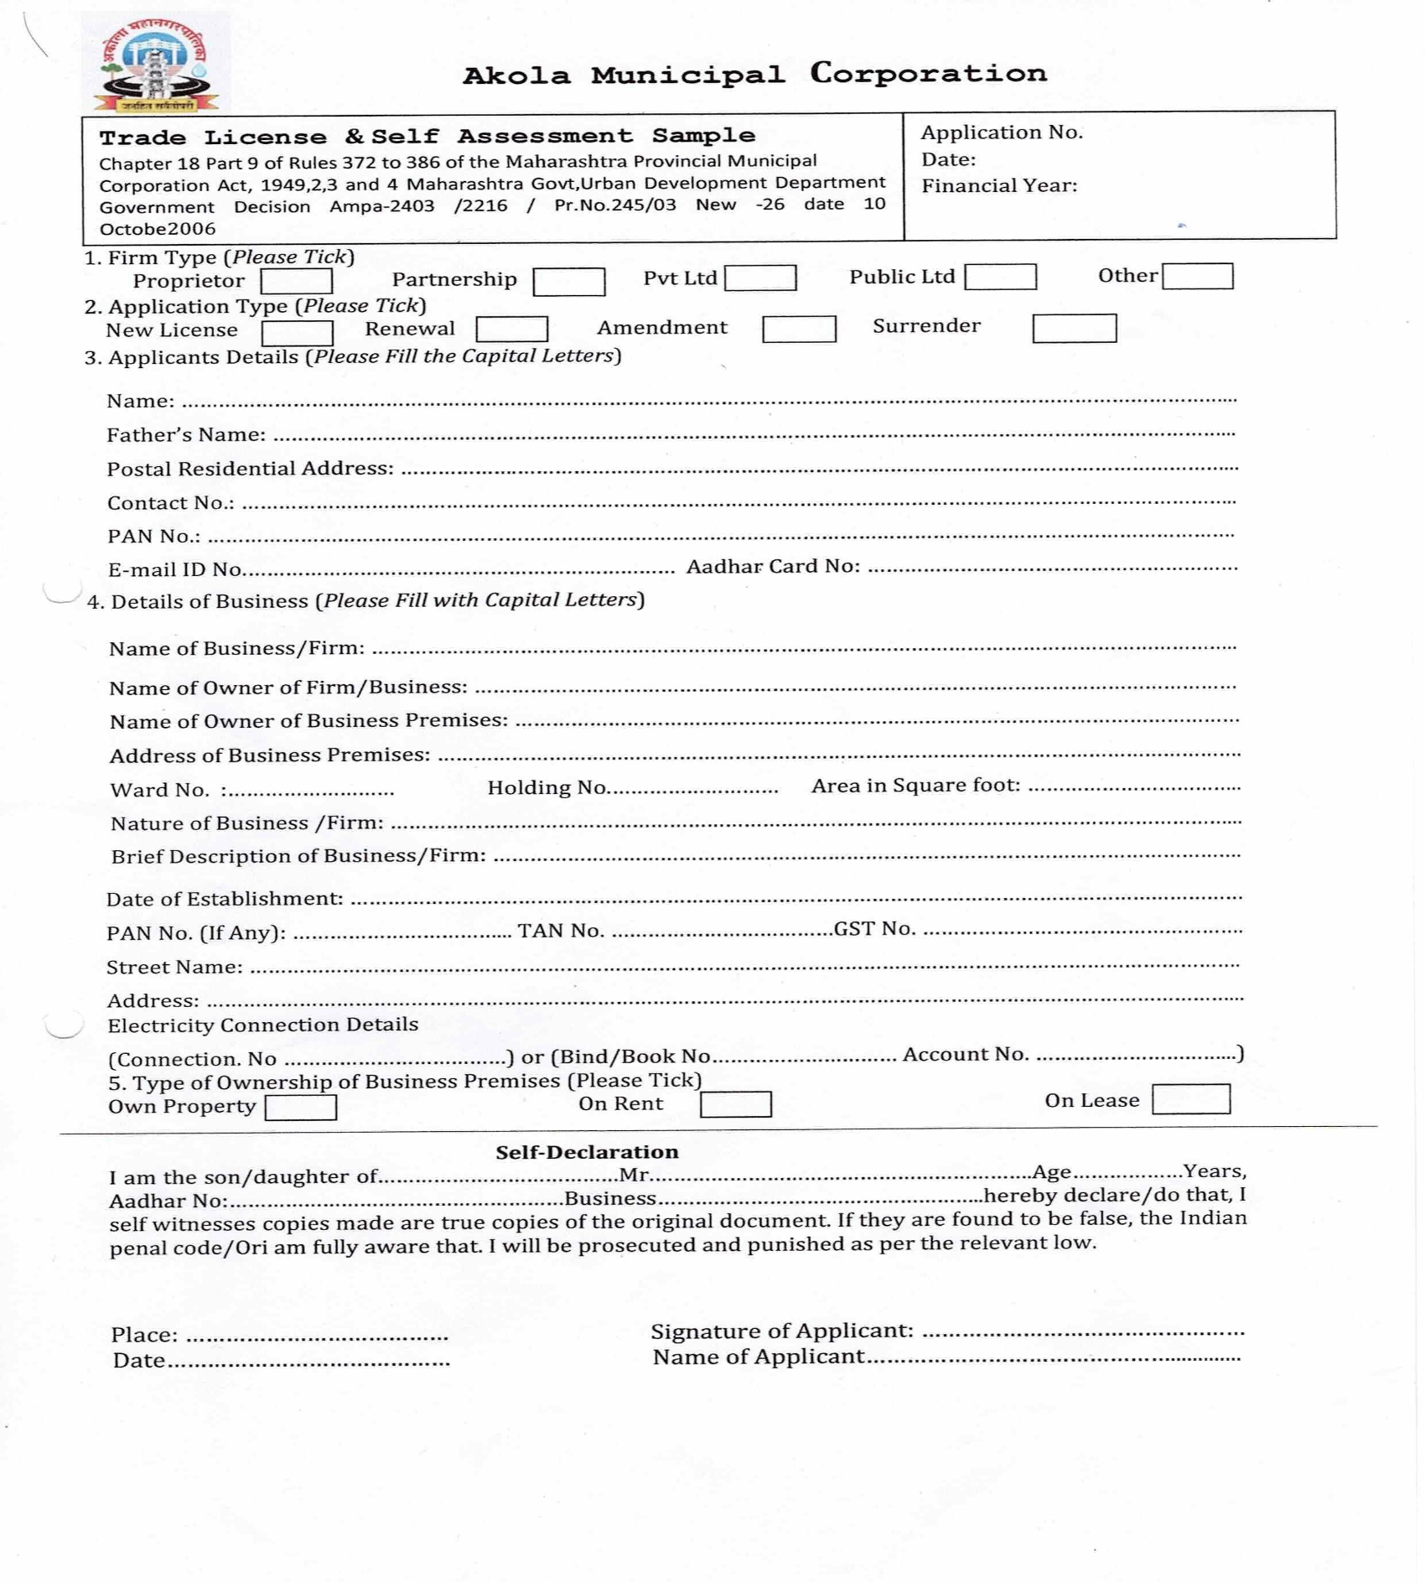**Trade Form and List of Documents**

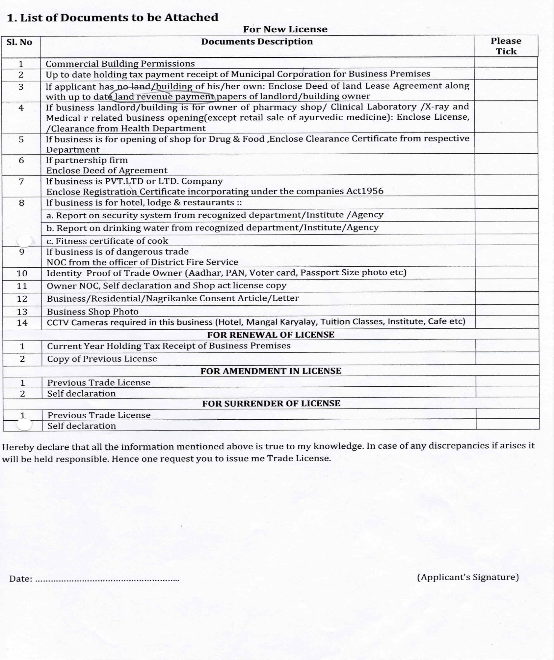

* 1. **Additional Requirements – (Update Tool)**

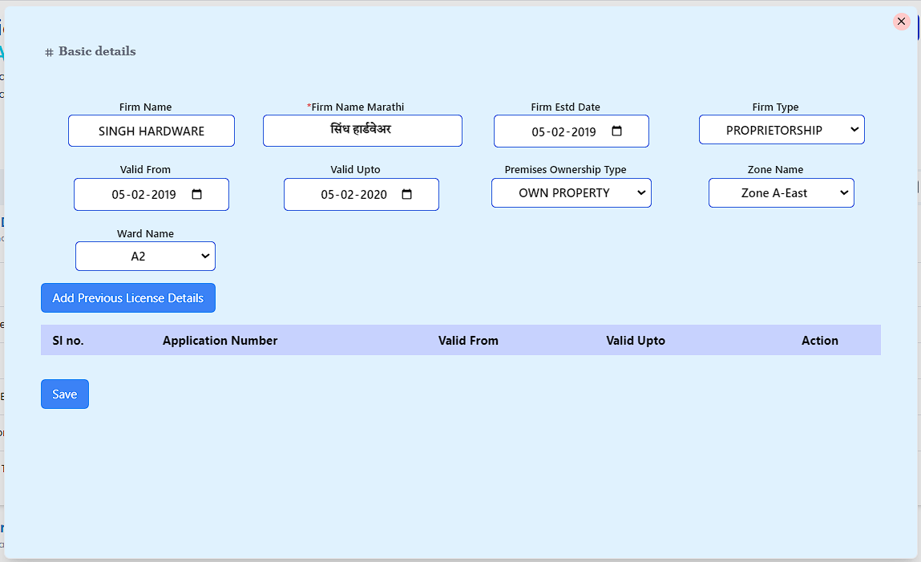

**Temporary Trade Licence**

* 1. Holding No. Validation

- Holding No. (for private property):

- Must be automatically fetched to verify property tax clearance status.

- Only if the property tax is cleared, the user can proceed.

- Government property: No Holding No. validation is required.

* 1. Application Date Logic

- The applicant can only apply for a 6-month duration (from the selected start date to end date).

- No restrictions on back-dating (previous dates allowed).

- During form filling, calculate fees as 200 * number of days and display in real-time.

* 1. Firm Establishment Details

- "Firm Establishment Date" will not be collected.

- Instead, capture "From Date" and "Up to Date" (limited to a 6-month period).

- Fees = 200 * number of days`, calculated automatically during form filling.

* 1. Trade License based on Holding No.

- If the property is commercial, multiple trade licenses can be applied under the same Holding No.

* 1. Applicant vs. Owner Details

- Owner details will be replaced by Applicant details in the form.

* 1. Property Type Selection

- At the beginning, the applicant must select Property Type:

- Private: Holding No. validation and property tax Arrear and Current clearance required.

- Government: No Holding No. validation required, and property tax demand is skipped.

* 1. Nature of Business & Fire NOC Requirement

- The nature of business will be predefined and shared by Sumit Sir.

- If the user selects another type of business:

- They will need to manually enter the business nature.

- Fire NOC becomes optional in such cases.

* 1. Firm Type and Applicant/Owner Structure

- Depending on the Firm Type, there can be multiple owners or applicants allowed.

- Ensure the system supports multiple entries for owners or applicants.

* 1. Application Limitation

- The system should allow users to apply for only 6 months at a time.

* 1. Approval Workflow with Escalation Logic

Lipik’s Approval:

If Lipik does not approve within 2 hours, the request will automatically forward to the Section Head.

Section Head’s Approval:

If the Section Head does not approve within 2 hours, the request will escalate to the DMC.

DMC Notification:

The DMC must be notified that the request has been escalated without prior approvals.

* 1. **How to apply New trade licence**

1. **JSK/Tax Collector and Citizen can apply New Trade licence**

**There are Four steps to complete the form**



Step -1- Select Firm Type and Primises ownership type

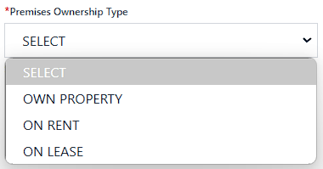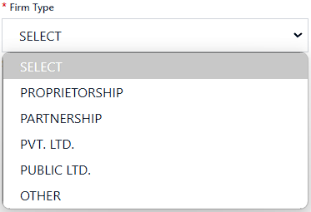

There are Five Types of firm and Three types of Premises ownership

Step -2- Firm details and business details

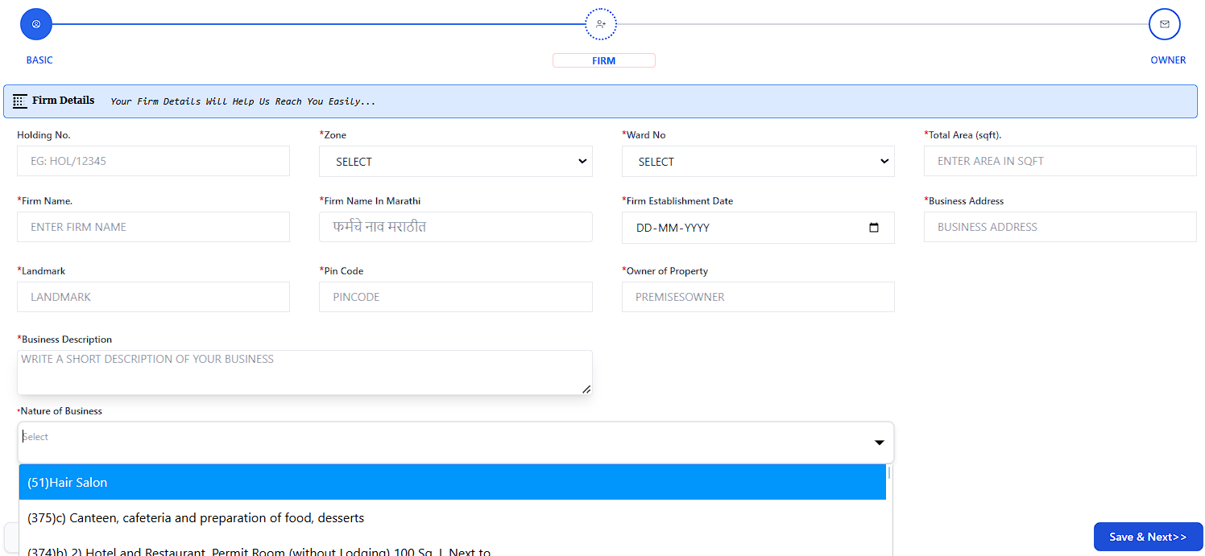

Condition -1- for Holding No : If Property owner is same as a Business premises owner it is required Holding Number before applying with updated holding payment receipt.

Condition -2- for holding No : If property owner is collect any types of rent of the business premises from the business owner, Holding number is required with uptodated holding payment receipt or rent agreement.

**Required Selection**

Zone - The zone to which the property belongs

Ward - The ward to which the property belongs

Total sqFt of business primeses - How much area is the business being conducted in?

Firm Name : What is the name of the firm?

Firm Establishment Date - When was the firm established?

Busniess Address - Where is the address of the firm?

Owner of property- What is the name of the owner of the property?

Business Description – What type of business is being done

Nature of Business - What is the type of business?

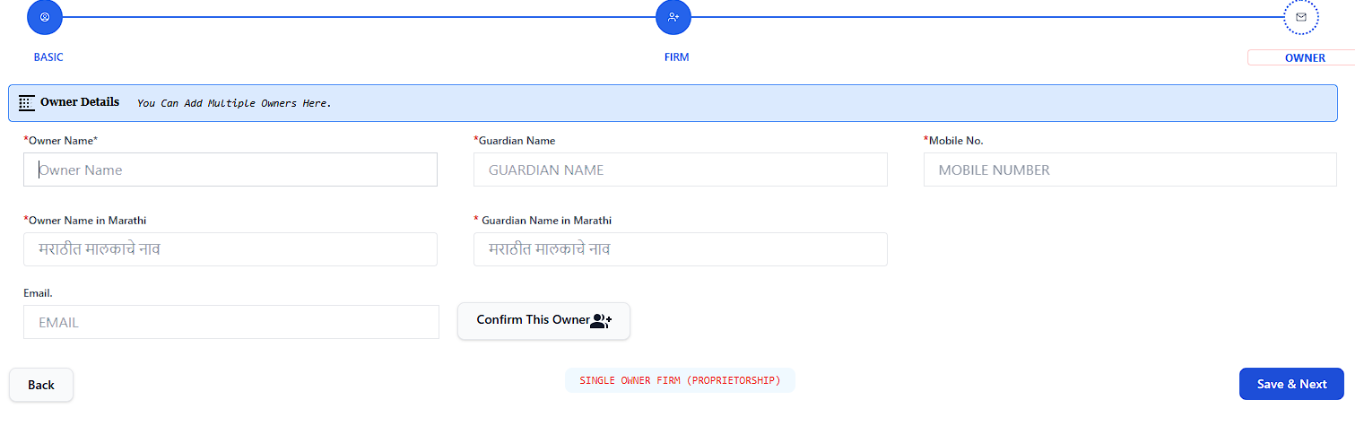Step- 3- Business Owner Details.

Business Owner Selection Details :

Owner Name : Who is the owner of business primes

Guardian Name: Name of Guardian

Mobile : Mobile number for information receive.

Email : Email is not mendatory

Owners : if Business type is Partnership then Add more owner.

Step-4- Payment Selection or Year selection, New Licence can apply only for One year.

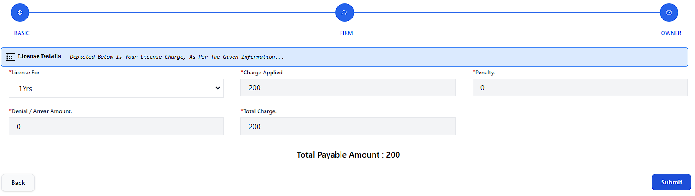

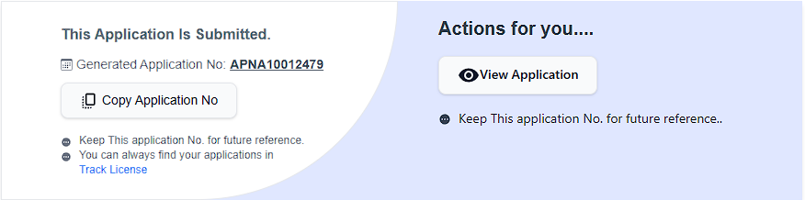Select One year and display amount as per rate fixed of Nature of Business codes. Then submit the button

After submit the button Sofware automatically generate an Unique Application Number.

1. **Uploading Documents of Applied Application Number.**



Open the application Number and click

Upload button for documents upload.



There are two steps of document upload.

First : Owners documents

1. Owner Photograph
2. Owner Business shop photograph
3. Identity Card

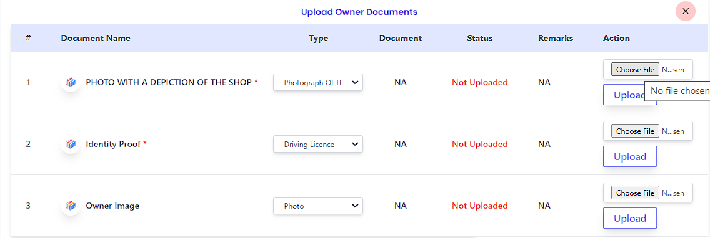

After Upload display this type

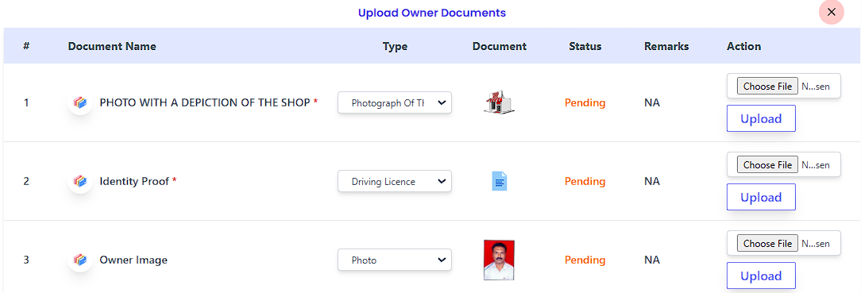

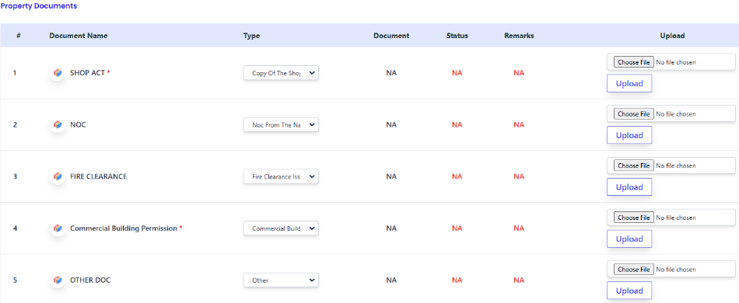Second : Necessory Documents



After successfully document uploaded then click on Send to next level button

1. **ULB Verification**
2. Clerical Level :

The clerk will open the application received in his inbox and verify all the given documents. If any kind of error is found in the documents, then the clerk can return the applied application to the citizen, otherwise after verifying all the documents. Will send it to the next level i.e. ATS.

1. ATS (Assitant Tax Suprintendent) Level :

Will open and view all the applications received in the ATS inbox and after viewing all the documents, will send it to the Tax Superintendent.

1. Tax Suprintendent Level :

The Tax Superintendent will open and view all the applications received in his inbox and approve them after reviewing all the documents.

1. Conclusion :

After the application is approved by the Tax Superintendent, he will again deposit the license fee at the Jan Suvidha Kendra and will receive the license fee payment receipt as well as a copy of the license. Apart from this, the citizen will be able to verify the application applied by the citizen with his login ID and password. He can make online payment from and can print a copy of the license: Also, if the citizen wants to print a copy of the license more than once, he will get it after paying Rs 25 online.

Clerical Level : लिपिक के द्वारा रिसीव किये गए एप्लीकेशन को अपने इनबॉक्स में ओपन कर के सभी दिए गए दस्तावेजों को वेरीफाई करेगा अगर दस्तावेजों में किसी प्रकार की त्रुटि पायी जाती है तो लिपिक अप्लाई किये गए एप्लीकेशन को बैक to सिटीजन कर सकता है अन्यथा सभी दस्तावेजों को वेरीफाई करके अगले लेवल में यानि ATS को भेज देगा।

Assitant Tax Suprintendent Level : ATS के इनबॉक्स में आये हुए सभी एप्लीकेशन को ओपन कर के देखेगा और सभी दस्तावेजों को देखने के बाद टैक्स सुपरिंटेंडेंट को भेज देगा।

Tax Suprintendent Level : टैक्स सुपरिंटेंडेंट अपने इनबॉक्स में आये हुए सभी एप्लीकेशन को ओपन कर के देखेगा और सभी दस्तावेजों को देखने के बाद approve कर देगा।

Conclusion :

टैक्स सुपरिंटेंडेंट के द्वारा एप्लीकेशन Approve होने के बाद पुनः जन सुविधा केंद्र में लाइसेंस फी जमा करेगा और लाइसेंस की फी की भुगतान receipt के साथ साथ लाइसेंस की प्रति कॉपी प्राप्त करेगा इसके अलावा सिटीजन के द्वारा अप्लाई किये गए एप्लीकेशन को सिटीजन अपने लॉगिन ID एवं पासवर्ड से ऑनलाइन भुगतान कर सकता है और लाइसेंस की प्रति कॉपी प्रिंट कर सकता है : साथ ही सिटीजन एक बार से ज्यादा लाइसेंस की प्रति कॉपी प्रिंट करना चाहे तो उसे 25 रूपए का भुगतान ऑनलाइन ही करने के उपरान्त प्राप्त होगा।

* 1. **Renewal of Trade Licence**

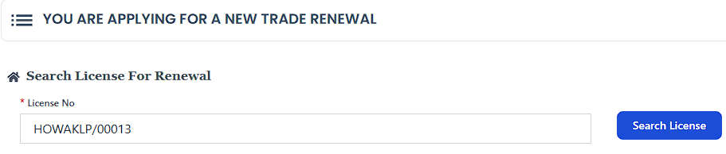For Renewal there are four steps is an important part of renewal to the licence

1. Step- 1- Fill licence number and search.

After Search showing the licence details



Click on Apply Renewal

1. Step-2 – Select the basic details as per documents

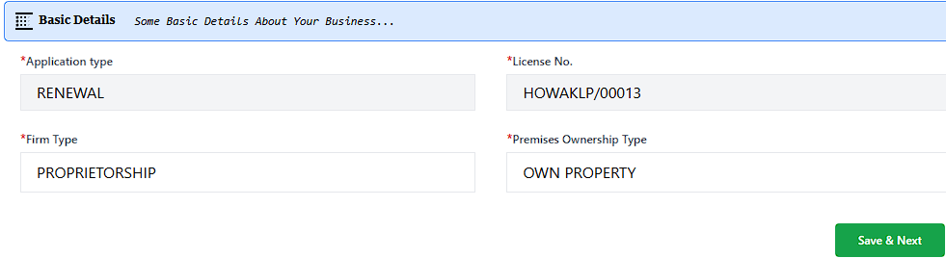

1. Fill Firm details as per documents

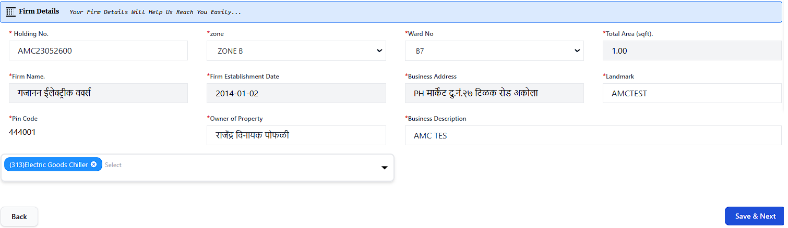

1. Update the owner details

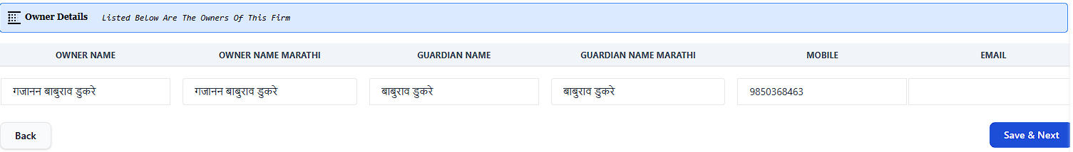

1. 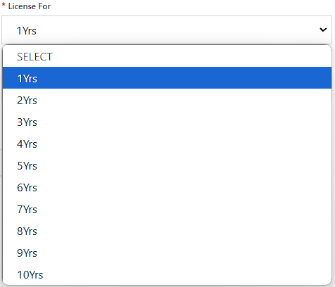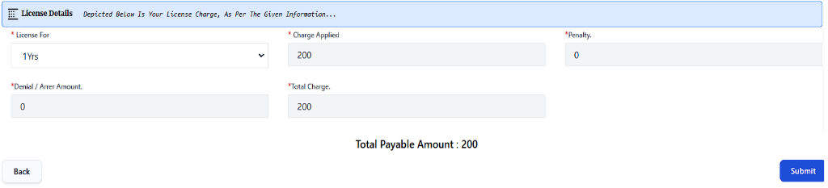Select the Year for how many years to apply renewal the licence.

You can also apply for renewal for more than one year, the calculation of which will be decided as per the Code of Nature of Business.